SEC Form 3
FORM 3 | UNITED STATES SECURITIES AND EXCHANGE COMMISSION
 | Washington, D.C. 20549
 | Washington, D.C. 20549 |  | OMB APPROVAL
 | INITIAL STATEMENT OF BENEFICIAL OWNERSHIP OF SECURITIES
 | INITIAL STATEMENT OF BENEFICIAL OWNERSHIP OF SECURITIES |  | OMB Number: | 3235-0104
 |  |  | Estimated average burden
 | Filed pursuant to Section 16(a) of the Securities Exchange Act of 1934 |  | hours per response: | 0.5
or Section 30(h) of the Investment Company Act of 1940
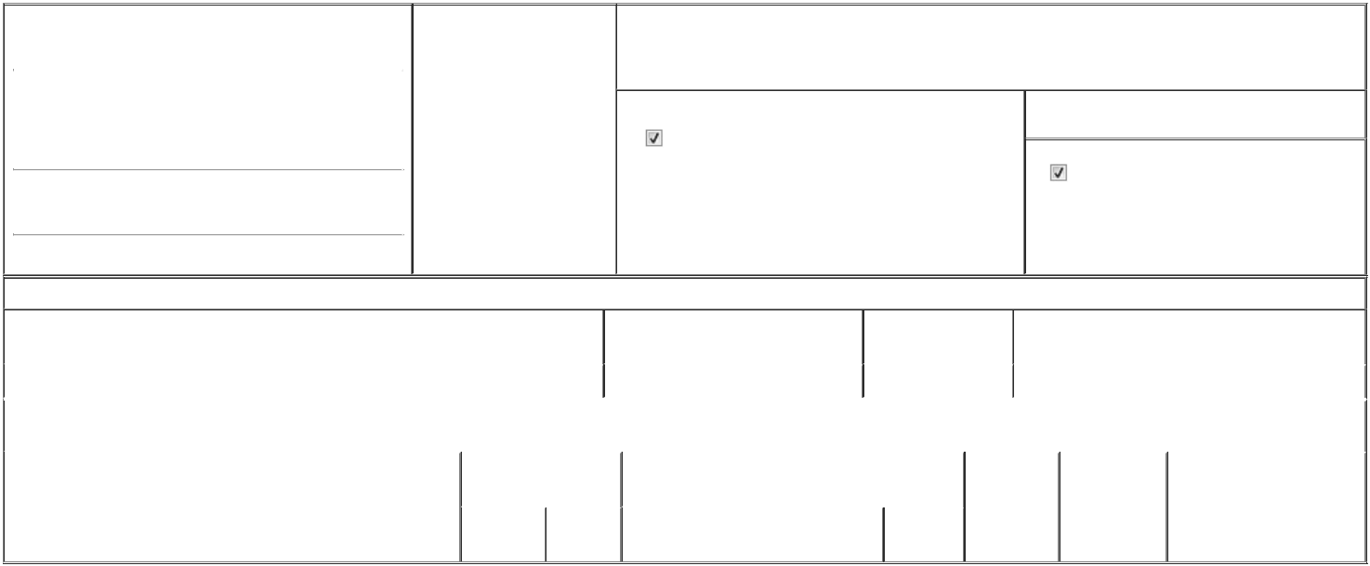

1. Name and Address of Reporting Person* |  |  |  |  |  | 2. Date of Event Requiring
 |  | Ryan Janice |  |  |  | Statement (Month/Day/Year)
 |  | Ryan Janice |  |  | 06/03/2025
 |  | (Last) |  | (First) | (Middle)

3. Issuer Name and Ticker or Trading Symbol

WESTWOOD HOLDINGS GROUP INC [ WHG ]

200 CRESCENT COURT
SUITE 1200
(Street)
DALLAS | TX | 75201

- Relationship of Reporting Person(s) to Issuer (Check all applicable)

Director | 10% Owner
Officer (give title | Other (specify below)
below) | Other (specify below)

- If Amendment, Date of Original Filed (Month/Day/Year)

- Individual or Joint/Group Filing (Check Applicable Line)

Form filed by One Reporting Person

Form filed by More than One Reporting Person

(City) (State) (Zip)

Table I - Non-Derivative Securities Beneficially Owned

1. Title of Security (Instr. 4) | 2. Amount of Securities Beneficially | 3. Ownership Form: | 4. Nature of Indirect Beneficial Ownership (Instr. 5)
 | Owned (Instr. 4) | Direct (D) or Indirect
 |  | (I) (Instr. 5)

 | common stock |  |  |  | 0 | D
 |  |  | Table II - Derivative Securities Beneficially Owned
 |  | (e.g., puts, calls, warrants, options, convertible securities)
 | 1. Title of Derivative Security (Instr. 4) |  | 2. Date Exercisable and |  | 3. Title and Amount of Securities Underlying |  | 4. | 5. Ownership | 6. Nature of Indirect Beneficial
 |  |  | Expiration Date |  | Derivative Security (Instr. 4) |  | Conversion | Form: Direct | Ownership (Instr. 5)
 |  |  | (Month/Day/Year) |  |  |  | or Exercise | (D) or Indirect
 |  |  |  |  |  |  | Price of | (I) (Instr. 5)
 |  |  |  |  |  | Amount or | Price of | (I) (Instr. 5)
 |  |  |  |  |  | Amount or | Derivative
 |  |  | Date | Expiration | Title | Number of | Security
 |  |  | Exercisable | Date | Title | Shares

Explanation of Responses:

Remarks:

Janice Ryan was appointed to WHG's Board of Directors on June 3, 2025. The delay in filing is due to enrollment in EDGAR Next.

Jonathan Richard Nahhat by POA from

Janice Ryan

** Signature of Reporting Person

Reminder: Report on a separate line for each class of securities beneficially owned directly or indirectly.

* If the form is filed by more than one reporting person, see Instruction 5 (b)(v).

- Intentional misstatements or omissions of facts constitute Federal Criminal Violations See 18 U.S.C. 1001 and 15 U.S.C. 78ff(a). Note: File three copies of this Form, one of which must be manually signed. If space is insufficient, see Instruction 6 for procedure.
Persons who respond to the collection of information contained in this form are not required to respond unless the form displays a currently valid OMB Number.

06/20/2025

Date





