SEC Form 4
FORM 4 |  | UNITED STATES SECURITIES AND EXCHANGE COMMISSION  Washington, D.C. 20549  STATEMENT OF CHANGES IN BENEFICIAL OWNERSHIP  Filed pursuant to Section 16(a) of the Securities Exchange Act of 1934  or Section 30(h) of the Investment Company Act of 1940
  OMB APPROVAL
  OMB Number: | 3235-0287
  Estimated average burden
  hours per response: | 0.5
 | Check this box if no longer subject to Section 16. Form 4 or Form 5 obligations may continue. See Instruction 1(b).
 | Check this box to indicate that a transaction was made pursuant to a contract, instruction or written plan for the purchase or sale of equity securities of the issuer that is intended to satisfy the affirmative defense conditions of Rule 10b5-1(c). See Instruction 10.
1. Name and Address of Reporting Person*  (Street) | 2. Issuer Name and Ticker or Trading Symbol  WESTWOOD HOLDINGS GROUP INC [ WHG ] | 5. Relationship of Reporting Person(s) to Issuer  (Check all applicable)
  MASTERSON ELLEN H
  (Last) | (First) | (Middle)
  200 CRESCENT COURT
  SUITE 1200
  DALLAS | TX | 75201
  (City) | (State) | (Zip)
   | Director |  | 10% Owner
   | Officer (give title below) |  | Other (specify below)
3. Date of Earliest Transaction (Month/Day/Year)
04/30/2025
 | 4. If Amendment, Date of Original Filed (Month/Day/Year) | 6. Individual or Joint/Group Filing (Check Applicable Line)
  Form filed by One Reporting Person
  Form filed by More than One Reporting Person
Table I - Non-Derivative Securities Acquired, Disposed of, or Beneficially Owned
1. Title of Security (Instr. 3) | 2. Transaction Date (Month/Day/Year) | 2A. Deemed Execution Date, if any (Month/Day/Year) | 3. Transaction Code (Instr. 8) |  | 4. Securities Acquired (A) or Disposed Of (D) (Instr. 3, 4 and 5) |  |  | 5. Amount of Securities Beneficially Owned Following Reported Transaction(s) (Instr. 3 and 4) | 6. Ownership Form: Direct (D) or Indirect (I) (Instr. 4) | 7. Nature of Indirect Beneficial Ownership (Instr. 4)
1. Title of Security (Instr. 3) | 2. Transaction Date (Month/Day/Year) | 2A. Deemed Execution Date, if any (Month/Day/Year) | Code | V | Amount | (A) or (D) | Price |  | 6. Ownership Form: Direct (D) or Indirect (I) (Instr. 4) | 7. Nature of Indirect Beneficial Ownership (Instr. 4)
common stock | 04/30/2025 |  | A |  | 5,690 | A | $0 | 46,834 | D
Table II - Derivative Securities Acquired, Disposed of, or Beneficially Owned
(e.g., puts, calls, warrants, options, convertible securities)
1. Title of Derivative Security (Instr. 3) | 2. Conversion or Exercise Price of Derivative Security | 3. Transaction Date (Month/Day/Year) | 3A. Deemed Execution Date, if any (Month/Day/Year) | 4. Transaction Code (Instr. 8) |  | 5. Number of Derivative Securities Acquired (A) or Disposed of (D) (Instr. 3, 4 and 5) |  | 6. Date Exercisable and Expiration Date (Month/Day/Year) |  | 7. Title and Amount of Securities Underlying Derivative Security (Instr. 3 and 4) |  | 8. Price of Derivative Security (Instr. 5) | 9. Number of derivative Securities Beneficially Owned Following Reported Transaction(s) (Instr. 4) | 10. Ownership Form: Direct (D) or Indirect (I) (Instr. 4) | 11. Nature of Indirect Beneficial Ownership (Instr. 4)
 |  |  |  | Code | V | (A) | (D) | Date Exercisable | Expiration Date | Title | Amount or Number of Shares
Explanation of Responses:
Remarks:
Director grants were awarded on April 30, 2025. The director grant award agreements were fully executed by the recipients on May 13, 2025. All directors have been enrolled in EDGAR Next, the completion of which occurred on May 23, 2025.
 | Jonathan Richard Nahhat, by POA from Ellen Masterson | 05/23/2025
 | ** Signature of Reporting Person | Date
Reminder: Report on a separate line for each class of securities beneficially owned directly or indirectly.
* If the form is filed by more than one reporting person, see Instruction 4 (b)(v).
** Intentional misstatements or omissions of facts constitute Federal Criminal Violations See 18 U.S.C. 1001 and 15 U.S.C. 78ff(a).
Note: File three copies of this Form, one of which must be manually signed. If space is insufficient, see Instruction 6 for procedure.
Persons who respond to the collection of information contained in this form are not required to respond unless the form displays a currently valid OMB Number.
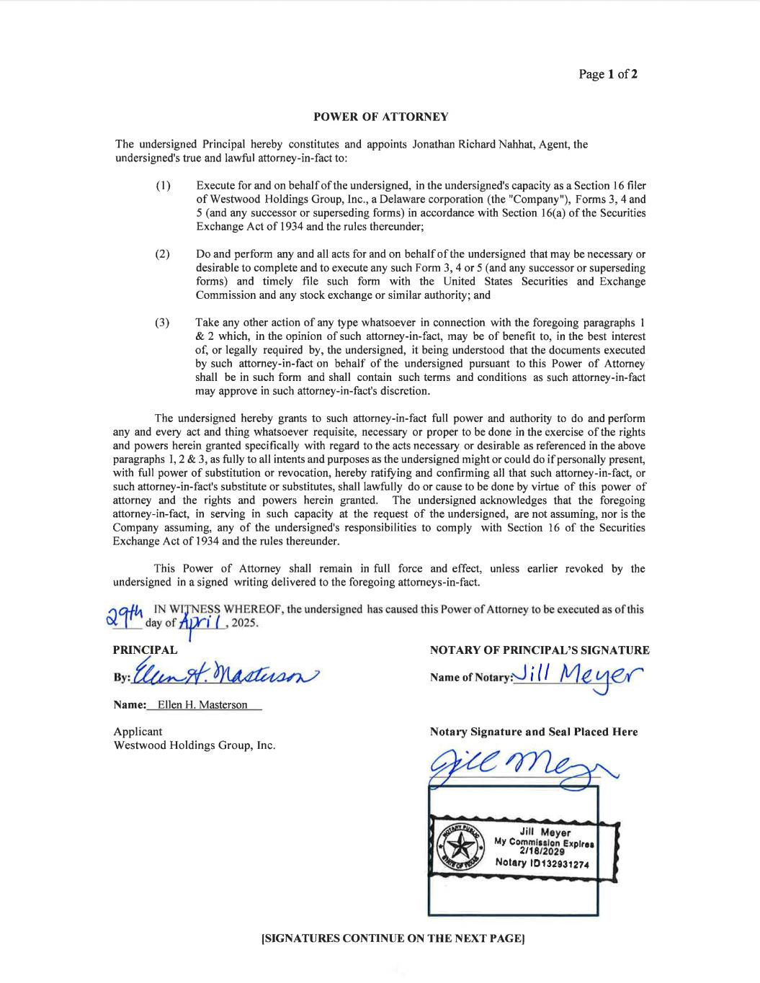
Page I of2 POWER OF ATTORNEY The undersigned Principal hereby constitutes and appoints Jonathan Richard Nahhat, Agent, the undersigned's true and lawful attorney-in-fact to: ( 1 ) Execute for and on behalfofthe undersigned, in the undersigned's capacity as a Section I 6 filer of Vy'estwood Holdings Group, Inc., a Delaware corporation (the "Company"), Forms 3, 4 and 5 (and any successor or superseding forms) in accordance with Section 16(a) ofthe Securities Exchange Act of 1 934 and the rules thereunder; (2) Do and perform ariy and all acts for and on behalfofthe undersigned that may be necessary or desirable to complete and to execute any such Form 3, 4 or 5 (and any successor or superseding forms) and timely file such form with the United States Securities and Exchange Commission and any stock exchange or similar authority; and (3) Take any other action ofany type whatsoever in connection with the foregoing paragraphs I &2 which, in the opinion of such attorney-in-fact, may be of benefit to, in the best interest of, or legally required by, the undersigned, it being understood that the documents executed by such attorney-in-fact on behalf ofthe undersigned pursuant to this Power of Attorney shall be in such form and shall contain such terms and conditions as such attorney-in-fact may approve in such attorney-in-fact's discretion. The undersigned hereby grants to such attorney-in-fact full power and authority to do and perform any and every act and thing whatsoever requisite, necessary or proper to be done in the exercise ofthe rights and powers herein granted specifically with regard to the acts necessary or desirable as referenced in the above paragraphs 1,2 &3, as fully to all intents and purposes as the undersigned might or could do if personally present, with full power of substitution or revocation, hereby ratiffing and conhrming all that such attomey-in-fact, or such attorney-in-fact's substitute or substitutes, shall lawfully do or cause to be done by virtue of this power of aftorney and the rights and po\¡/ers herein granted. The undersigned acknowledges that the foregoing attorney-in-fact, in serving in such capacity at the request of the undersigned, are not assuming, nor is the Company assuming, any of the undersigned's responsibilities to comply with Section 16 of the Securities Exchange Act of I 934 and the rules thereunder. This Power of Attorney shall remain in full force and effect, unless earlier revoked by the undersigned in a signed writing delivered to the foregoing attomeys-in-fact. 4A+lA IN V/IJNESS V/HEREOF, the undersigned has caused this Power of Attorney to be executed as ofthis o¿__ll_ day of AiT[ ( .2025. I PRINCIPAL NOTARY OF PRINCIPAL'S SIGNATURE Name of ill Name: Ellen H. Masterson Applicant Westwood Holdings Group, Inc. Notary Signature and Seal Placed Here Jill Mever Mv Co¡lmtratoå Exrhor Notsry lOl3293r¿7,f ISIGNATURES CONTINUE ON THE NEXT PAGEI

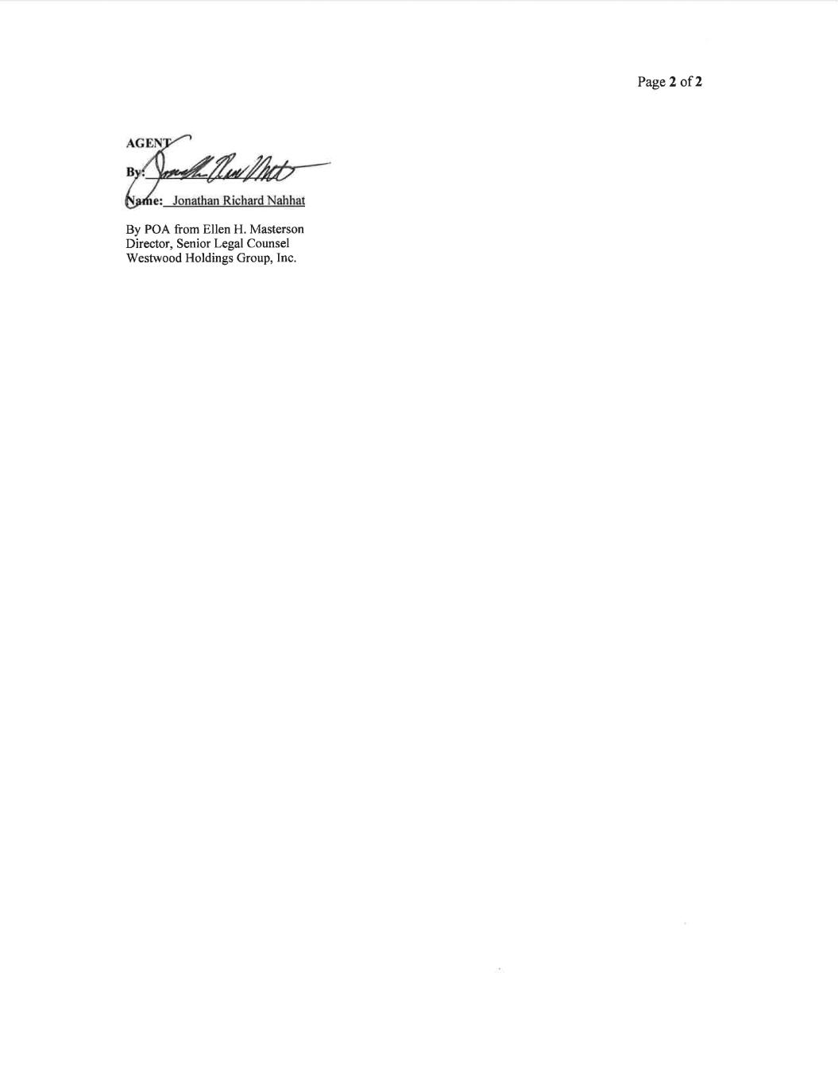
Page2 of2 By POA from Ellen H. Masterson Director, Senior Legal Counsel Westwood Holdings Group, Inc.

