____________________________________________________________________________________________________

UNITED STATES

SECURITIES AND EXCHANGE COMMISSION

Washington, D.C. 20549

____________________________________________________________________________________________________

FORM 10-Q

____________________________________________________________________________________________________

- Quarterly Report Pursuant to Section 13 or 15(d) of the Securities Exchange Act of 1934

For the quarterly period ended June 30, 2025

OR

- Transition Report Pursuant to Section 13 or 15(d) of the Securities Exchange Act of 1934

For the transition period from |  | to | .
Commission file number 1-31234
____________________________________________________________________________________________________

WESTWOOD HOLDINGS GROUP, INC.

(Exact name of registrant as specified in its charter)

____________________________________________________________________________________________________

Delaware | 75-2969997
(State or other jurisdiction of incorporation or organization) | (IRS Employer Identification No.)
200 CRESCENT COURT, SUITE 1200
DALLAS, Texas | 75201
(Address of principal executive office) | (Zip Code)
 | (214) 756-6900
 | (Registrant’s telephone number, including area code)
____________________________________________________________________________________________________

 |  |  | (Former name, former address and former fiscal year, if changed since last report)
 |  |  | Securities registered pursuant to Section 12(b) of the Act:
 | Title of Each Class |  |  | Trading Symbol |  | Name of Each Exchange on Which Registered
Common stock, par value $0.01 per share |  |  |  | WHG |  | New York Stock Exchange

Indicate by check mark whether the registrant (1) has filed all reports required to be filed by Section 13 or 15(d) of the Securities Exchange Act of 1934 during the preceding 12 months (or for such shorter period that the registrant was required to file such reports), and (2) has been subject to such filing requirements for the past 90 days. Yes ☒ No ☐

Indicate by check mark whether the registrant has submitted electronically every Interactive Data File required to be submitted pursuant to Rule 405 of Regulation S-T (§232.405 of this chapter) during the preceding 12 months (or for such shorter period that the registrant was required to submit such files). Yes ☒ No ☐

Indicate by check mark whether the registrant is a large accelerated filer, an accelerated filer, a non-accelerated filer, smaller reporting company, or an emerging growth company. See definition of “large accelerated filer,” “accelerated filer,” “smaller reporting company,” and “emerging growth company” in Rule 12b-2 of the Exchange Act.
Large accelerated filer | ☐ | Accelerated filer | ☐
Non-accelerated filer | ☒ | Smaller reporting company | ☒
 |  | Emerging growth company | ☐

If an emerging growth company, indicate by check mark if the registrant has elected not to use the extended transition period for complying with any new or revised accounting standards provided pursuant to Section 13(a) of the Exchange Act. ☐ Indicate by check mark whether the registrant is a shell company (as defined in Rule 12b-2 of the Exchange Act). Yes ☐ No ☒

Shares of common stock, par value $0.01 per share, outstanding as of August 1, 2025: 9,408,130.

____________________________________________________________________________________________________

 |  |  |  |  |  |  |  |  |  |  |  |  |  |  | WESTWOOD HOLDINGS GROUP, INC.
INDEX
 | PART I |  | FINANCIAL INFORMATION |  |  |  |  |  |  |  |  |  |  |  |  |  | PAGE
 | Item 1. |  | Financial Statements
 |  |  | Condensed Consolidated Balance Sheets |  |  |  |  |  |  |  |  |  |  |  |  |  | 1
 |  |  | Condensed Consolidated Statements of Operations |  |  |  |  |  |  |  |  |  |  |  |  |  | 2
 |  |  | Condensed Consolidated Statements of Stockholders’ Equity |  |  |  |  |  |  |  |  |  |  |  |  |  | 3
 |  |  | Condensed Consolidated Statements of Cash Flows |  |  |  |  |  |  |  |  |  |  |  |  |  | 5
 |  |  | Notes to Condensed Consolidated Financial Statements |  |  |  |  |  |  |  |  |  |  |  |  |  | 6
 | Item 2. |  | Management’s Discussion and Analysis of Financial Condition and Results of Operations |  |  |  |  |  |  |  |  |  |  |  |  |  | 16
 | Item 3. |  | Quantitative and Qualitative Disclosures About Market Risk |  |  |  |  |  |  |  |  |  |  |  |  |  | 23
 | Item 4. |  | Controls and Procedures |  |  |  |  |  |  |  |  |  |  |  |  |  | 23
 | PART II |  | OTHER INFORMATION |  |  |  |  |  |  |  |  |  |  |  |  |  | 24
 | Item 1. |  | Legal Proceedings |  |  |  |  |  |  |  |  |  |  |  |  |  | 24
 | Item 1A. |  | Risk Factors |  |  |  |  |  |  |  |  |  |  |  |  |  | 24
 | Item 2. |  | Unregistered Sales of Equity Securities and Use of Proceeds |  |  |  |  |  |  |  |  |  |  |  |  |  | 24
 | Item 6. |  | Exhibits |  |  |  |  |  |  |  |  |  |  |  |  |  | 25
 | Signatures |  |  |  |  |  |  |  |  |  |  |  |  |  |  |  | 26

WESTWOOD HOLDINGS GROUP, INC.

CONDENSED CONSOLIDATED BALANCE SHEETS

(In thousands, except par value and share amounts)

(Unaudited)

 | June 30, 2025 |  |  |  | December 31, 2024
ASSETS
Cash and cash equivalents | $ | 15,403 |  | $ | 18,847
Accounts receivable |  | 15,331 |  |  | 14,453
Investments, at fair value (amortized cost of $18,316 and $26,788) |  | 19,768 |  |  | 27,694
Investments under measurement alternative |  | 11,747 |  |  | 10,747
Equity method investments |  | 4,197 |  |  | 4,250
Income taxes receivable |  | 167 |  |  | 295
Other assets |  | 7,076 |  |  | 6,780
Goodwill |  | 39,501 |  |  | 39,501
Deferred income taxes |  | 2,356 |  |  | 2,244
Operating lease right-of-use assets |  | 9,997 |  |  | 2,559
Intangible assets, net |  | 20,035 |  |  | 21,668
Property and equipment, net of accumulated depreciation of $8,716 and $8,424 |  | 701 |  |  | 951
Total assets | $ | 146,279 |  | $ | 149,989
LIABILITIES AND STOCKHOLDERS' EQUITY
Accounts payable and accrued liabilities | $ | 5,304 |  | $ | 6,413
Dividends payable |  | 2,430 |  |  | 2,466
Compensation and benefits payable |  | 5,719 |  |  | 10,924
Operating lease liabilities |  | 10,468 |  |  | 3,197
Contingent consideration |  | — |  |  | 4,657
Total liabilities |  | 23,921 |  |  | 27,657
Commitments and contingencies (Note 10)
Stockholders' Equity:
Common stock, $0.01 par value, authorized 25,000,000 shares, issued 12,391,817 and 12,137,080, respectively and outstanding 9,408,125 and
9,234,575, respectively |  | 124 |  |  | 122
Additional paid-in capital |  | 203,594 |  |  | 202,239
Treasury stock, at cost – 2,983,692 and 2,902,505, respectively |  | (89,612) |  |  | (88,277)
Retained earnings |  | 6,200 |  |  | 6,207
Total Westwood Holdings Group, Inc. stockholders’ equity |  | 120,306 |  |  | 120,291
Noncontrolling interest in consolidated subsidiary |  | 2,052 |  |  | 2,041
Total equity |  | 122,358 |  |  | 122,332
Total liabilities and stockholders' equity | $ | 146,279 |  | $ | 149,989

See Notes to Condensed Consolidated Financial Statements.

1

WESTWOOD HOLDINGS GROUP, INC.

CONDENSED CONSOLIDATED STATEMENTS OF OPERATIONS

(In thousands, except per share data and share amounts)

(Unaudited)

 | Three Months Ended June 30, |  |  |  |  |  |  | Six Months Ended June 30,
 | 2025 |  |  | 2024 |  |  |  | 2025 |  |  | 2024
REVENUES:
Advisory fees:
Asset-based | $ | 17,955 |  | $ | 17,139 |  | $ | 35,686 |  | $ | 33,956
Trust fees |  | 5,069 |  |  | 5,227 |  |  | 10,498 |  |  | 10,340
Other, net |  | 96 |  |  | 322 |  |  | 188 |  |  | 1,124
Total revenues |  | 23,120 |  |  | 22,688 |  |  | 46,372 |  |  | 45,420
EXPENSES:
Employee compensation and benefits |  | 13,472 |  |  | 13,638 |  |  | 27,973 |  |  | 28,349
Sales and marketing |  | 657 |  |  | 755 |  |  | 1,417 |  |  | 1,383
Westwood mutual funds |  | 957 |  |  | 855 |  |  | 1,854 |  |  | 1,576
Information technology |  | 2,704 |  |  | 2,350 |  |  | 5,371 |  |  | 4,640
Professional services |  | 1,486 |  |  | 1,450 |  |  | 3,099 |  |  | 2,939
General and administrative |  | 2,976 |  |  | 3,011 |  |  | 5,858 |  |  | 5,912
Loss from change in fair value of contingent consideration |  | — |  |  | 4,807 |  |  | — |  |  | 1,858
Total expenses |  | 22,252 |  |  | 26,866 |  |  | 45,572 |  |  | 46,657
Net operating income (loss) |  | 868 |  |  | (4,178) |  |  | 800 |  |  | (1,237)
Net investment income |  | 343 |  |  | 548 |  |  | 726 |  |  | 1,003
Other income |  | 257 |  |  | 224 |  |  | 534 |  |  | 409
Income (loss) before income taxes |  | 1,468 |  |  | (3,406) |  |  | 2,060 |  |  | 175
Income tax provision |  | 437 |  |  | (1,193) |  |  | 552 |  |  | 222
Net income (loss) | $ | 1,031 |  | $ | (2,213) |  | $ | 1,508 |  | $ | (47)
Less: income (loss) attributable to noncontrolling interest
Less: income (loss) attributable to noncontrolling interest |  | 12 |  |  | 30 |  |  | 11 |  |  | (100)
Income (loss) attributable to Westwood Holdings Group, Inc. | $ | 1,019 |  | $ | (2,243) |  | $ | 1,497 |  | $ | 53
Earnings (loss) per share:
Basic | $ | 0.12 |  | $ | (0.27) |  | $ | 0.18 |  | $ | 0.01
Diluted | $ | 0.12 |  | $ | (0.27) |  | $ | 0.17 |  | $ | 0.01
Weighted average shares outstanding:
Basic |  | 8,404,859 |  |  | 8,218,596 |  |  | 8,329,803 |  |  | 8,158,812
Diluted |  | 8,813,606 |  |  | 8,218,596 |  |  | 8,798,092 |  |  | 8,438,431

See Notes to Condensed Consolidated Financial Statements.

2

WESTWOOD HOLDINGS GROUP, INC.

CONDENSED CONSOLIDATED STATEMENTS OF STOCKHOLDERS’ EQUITY

For the Three Months Ended June 30, 2025 and 2024

(In thousands, except share amounts)

(Unaudited)

 | Common Stock, Par |  |  |  |  | Additional Paid-In
 | Shares |  |  | Amount |  |  | Capital |  |  | Treasury Stock |  |  | Retained Earnings |  |  | Noncontrolling Interest |  |  | Total
Balance, March 31, 2025 | 9,379,675 |  | $ | 124 |  | $ | 202,299 |  | $ | (89,612) |  | $ | 6,535 |  | $ | 2,040 |  | $ | 121,386
Net income | — |  |  | — |  |  | — |  |  | — |  |  | 1,019 |  |  | 12 |  |  | 1,031
Issuance of restricted stock, net of forfeitures | 28,450 |  |  | — |  |  | — |  |  | — |  |  | — |  |  | — |  |  | —
Dividends declared ($0.15 per share) | — |  |  | — |  |  | — |  |  | — |  |  | (1,354) |  |  | — |  |  | (1,354)
Stock-based compensation expense | — |  |  | — |  |  | 1,295 |  |  | — |  |  | — |  |  | — |  |  | 1,295
Balance, June 30, 2025 | 9,408,125 |  | $ | 124 |  | $ | 203,594 |  | $ | (89,612) |  | $ | 6,200 |  | $ | 2,052 |  | $ | 122,358
 | Common Stock, Par |  |  |  |  | Additional Paid-In
 | Shares |  |  | Amount |  |  | Capital |  |  | Treasury Stock |  |  | Retained Earnings |  |  | Noncontrolling Interest |  |  | Total
Balance, March 31, 2024 | 9,330,762 |  | $ | 122 |  | $ | 201,899 |  | $ | (86,930) |  | $ | 6,749 |  | $ | 1,915 |  | $ | 123,755
Net income (loss) | — |  |  | — |  |  | — |  |  | — |  |  | (2,243) |  |  | 30 |  |  | (2,213)
Issuance of restricted stock, net of forfeitures | 49,031 |  |  | 1 |  |  | (1) |  |  | — |  |  | — |  |  | — |  |  | —
Dividends declared ($0.15 per share) | — |  |  | — |  |  | (1,231) |  |  | — |  |  | (167) |  |  | — |  |  | (1,398)
Stock-based compensation expense | — |  |  | — |  |  | 1,397 |  |  | — |  |  | — |  |  | — |  |  | 1,397
Purchases of treasury stock | (86,346) |  |  | — |  |  | — |  |  | (1,075) |  |  | — |  |  | — |  |  | (1,075)
Balance, June 30, 2024 | 9,293,447 |  | $ | 123 |  | $ | 202,064 |  | $ | (88,005) |  | $ | 4,339 |  | $ | 1,945 |  | $ | 120,466

See Notes to Condensed Consolidated Financial Statements.

3

WESTWOOD HOLDINGS GROUP, INC.

CONDENSED CONSOLIDATED STATEMENTS OF STOCKHOLDERS’ EQUITY

For the Six Months Ended June 30, 2025 and 2024

(In thousands, except share amounts)

(Unaudited)

 |  |  | Common Stock, Par |  |  |  |  |  |  |  |  | Additional Paid-In
 |  |  | Shares |  |  |  |  | Amount |  |  |  |  | Capital |  |  |  |  | Treasury Stock |  |  |  |  | Retained Earnings |  |  |  |  | Noncontrolling Interest |  |  |  |  | Total
Balance, December 31, 2024 |  | 9,234,575 |  |  |  | $ |  | 122 |  |  | $ |  | 202,239 |  |  | $ |  | (88,277) |  |  | $ |  | 6,207 |  |  |  | $ | 2,041 |  |  |  | $ | 122,332
Net income |  |  | — |  |  |  |  | — |  |  |  |  | — |  |  |  |  | — |  |  |  |  | 1,497 |  |  |  |  | 11 |  |  |  |  | 1,508
Issuance of restricted stock, net of forfeitures |  | 254,737 |  |  |  |  |  | 2 |  |  |  |  | (2) |  |  |  |  | — |  |  |  |  | — |  |  |  |  | — |  |  |  |  | —
Dividends declared ($0.30 per share) |  |  | — |  |  |  |  | — |  |  |  |  | (1,265) |  |  |  |  | — |  |  |  |  | (1,504) |  |  |  |  | — |  |  |  |  | (2,769)
Stock-based compensation expense |  |  | — |  |  |  |  | — |  |  |  |  | 2,622 |  |  |  |  | — |  |  |  |  | — |  |  |  |  | — |  |  |  |  | 2,622
Restricted stock returned for payment of taxes |  | (81,187) |  |  |  |  |  | — |  |  |  |  | — |  |  |  |  | (1,335) |  |  |  |  | — |  |  |  |  | — |  |  |  |  | (1,335)
Balance, June 30, 2025 |  | 9,408,125 |  |  |  | $ |  | 124 |  |  | $ |  | 203,594 |  |  | $ |  | (89,612) |  |  | $ |  | 6,200 |  |  |  | $ | 2,052 |  |  |  | $ | 122,358
 |  |  | Common Stock, Par |  |  |  |  |  |  |  |  | Additional Paid-In
 |  |  | Shares |  |  |  |  | Amount |  |  |  |  | Capital |  |  |  |  | Treasury Stock |  |  |  |  | Retained Earnings |  |  |  |  | Noncontrolling Interest |  |  |  |  | Total
 | Balance, December 31, 2023 |  | 9,140,760 |  |  |  | $ | 119 |  |  |  | $ | 201,622 |  |  |  | $ | (85,990) |  |  |  | $ | 4,650 |  |  | $ |  | 2,045 |  |  | $ |  | 122,446
 | Net income (loss) |  | — |  |  |  |  | — |  |  |  |  | — |  |  |  |  | — |  |  |  |  | 53 |  |  |  |  | (100) |  |  |  |  | (47)
 | Issuance of restricted stock, net of forfeitures | 317,336 |  |  |  |  |  | 4 |  |  |  |  | (4) |  |  |  |  | — |  |  |  |  | — |  |  |  |  | — |  |  |  |  | —
 | Dividends declared ($0.30 per share) |  | — |  |  |  |  | — |  |  |  |  | (2,466) |  |  |  |  | — |  |  |  |  | (364) |  |  |  |  | — |  |  |  |  | (2,830)
 | Stock-based compensation expense |  | — |  |  |  |  | — |  |  |  |  | 2,912 |  |  |  |  | — |  |  |  |  | — |  |  |  |  | — |  |  |  |  | 2,912
 | Purchases of treasury stock | (86,346) |  |  |  |  |  | — |  |  |  |  | — |  |  |  |  | (1,075) |  |  |  |  | — |  |  |  |  | — |  |  |  |  | (1,075)
 | Restricted stock returned for payment of taxes | (78,303) |  |  |  |  |  | — |  |  |  |  | — |  |  |  |  | (940) |  |  |  |  | — |  |  |  |  | — |  |  |  |  | (940)
 | Balance, June 30, 2024 |  | 9,293,447 |  |  |  | $ | 123 |  |  |  | $ | 202,064 |  |  |  | $ | (88,005) |  |  |  | $ | 4,339 |  |  | $ |  | 1,945 |  |  | $ |  | 120,466

See Notes to Condensed Consolidated Financial Statements.

4

WESTWOOD HOLDINGS GROUP, INC.

CONDENSED CONSOLIDATED STATEMENTS OF CASH FLOWS

(In thousands)

(Unaudited)

 |  | Six Months Ended June 30,
 | 2025 |  |  |  | 2024
CASH FLOWS FROM OPERATING ACTIVITIES:
Net income (loss) | $ | 1,508 |  | $ | (47)
Adjustments to reconcile net income (loss) to net cash provided by operating activities:
Depreciation |  | 257 |  |  | 326
Amortization of intangible assets |  | 2,082 |  |  | 2,074
Net change in unrealized (appreciation) depreciation on investments |  | 137 |  |  | (1,004)
Stock-based compensation expense |  | 2,622 |  |  | 2,912
Deferred income taxes |  | (112) |  |  | (47)
Non-cash lease expense |  | 694 |  |  | 546
Fair value change of contingent consideration |  | — |  |  | 1,858
Change in operating assets and liabilities:
Accounts receivable |  | (878) |  |  | 70
Other assets |  | (296) |  |  | 2
Accounts payable and accrued liabilities |  | (1,139) |  |  | (814)
Compensation and benefits payable |  | (5,205) |  |  | (4,217)
Income taxes receivable |  | 128 |  |  | (740)
Other liabilities |  | (795) |  |  | (664)
Net sales of trading securities |  | 7,842 |  |  | 11,430
Contingent consideration |  | (4,442) |  |  | —
Net cash provided by operating activities |  | 2,403 |  |  | 11,685
CASH FLOWS FROM INVESTING ACTIVITIES:
Purchase of property and equipment |  | (6) |  |  | (24)
Purchase of investments |  | (1,000) |  |  | (1,500)
Additions to internally developed software |  | (449) |  |  | —
Net cash used in investing activities |  | (1,455) |  |  | (1,524)
CASH FLOWS FROM FINANCING ACTIVITIES:
Purchases of treasury stock |  | — |  |  | (1,075)
Restricted stock returned for payment of taxes |  | (1,335) |  |  | (940)
Payment of contingent consideration in acquisition |  | (201) |  |  | (1,815)
Cash dividends paid |  | (2,856) |  |  | (2,983)
Net cash used in financing activities |  | (4,392) |  |  | (6,813)
NET CHANGE IN CASH AND CASH EQUIVALENTS |  | (3,444) |  |  | 3,348
Cash and cash equivalents, beginning of period |  | 18,847 |  |  | 20,422
Cash and cash equivalents, end of period | $ | 15,403 |  | $ | 23,770
SUPPLEMENTAL CASH FLOW INFORMATION:
Cash paid during the period for income taxes | $ | 535 |  | $ | 1,008
Accrued dividends | $ | 2,430 |  | $ | 2,176
Operating lease assets obtained in exchange for operating lease liabilities | $ | 8,133 |  | $ | —

See Notes to Condensed Consolidated Financial Statements.

5

WESTWOOD HOLDINGS GROUP, INC.

NOTES TO CONDENSED CONSOLIDATED FINANCIAL STATEMENTS

(Unaudited)

1. DESCRIPTION OF THE BUSINESS

Westwood Holdings Group, Inc. (“Westwood”, “the Company”, “we”, “us” or “our”) was incorporated under the laws of the State of Delaware on December 12, 2001. Westwood manages investment assets and provides services for its clients through its subsidiaries, Westwood Management Corp., Westwood Advisors, L.L.C., Salient Advisors, L.P. and Broadmark Asset Management LLC, (referred to hereinafter together as “Westwood Management”), and Westwood Trust.

Westwood Management provides investment advisory services to institutional clients, a family of mutual funds called the Westwood Funds®, other mutual funds, individual investors and clients of Westwood Trust. Westwood Trust provides trust and custodial services and participation in self-sponsored common trust funds ("CTFs") to institutions and high net worth individuals. Revenue is largely dependent on the total value and composition of assets under management ("AUM") and assets under advisement ("AUA"), and fluctuations in financial markets and in the composition of AUM impact our revenues and results of operations.

Westwood Management is registered with the Securities and Exchange Commission ("SEC") as an investment adviser under the Investment Advisers Act of 1940, as amended. Westwood Trust is chartered and regulated by the Texas Department of Banking.

- SUMMARY OF SIGNIFICANT ACCOUNTING POLICIES Basis of Presentation
The accompanying Condensed Consolidated Financial Statements are unaudited and are presented in accordance with the requirements for quarterly reports on Form 10-Q and consequently do not include all of the information and footnote disclosures required by accounting principles generally accepted in the United States of America ("GAAP"). The Company’s Condensed Consolidated Financial Statements reflect all adjustments (consisting only of normal recurring adjustments) necessary to a fair statement of our interim financial position and results of operations and cash flows for the periods presented. The accompanying Condensed Consolidated Financial Statements are presented in accordance with GAAP and the rules and regulations of the SEC. The Condensed Consolidated Balance Sheets have been reclassified to unclassified balance sheets to better reflect the nature of the Company’s operations. Prior year amounts have been reclassified for consistency with the current year presentation.

The accompanying unaudited Condensed Consolidated Financial Statements should be read in conjunction with our Consolidated Financial Statements, and notes thereto, included in our Annual Report on Form 10-K for the year ended December 31, 2024. Operating results for the periods in these Condensed Consolidated Financial Statements are not necessarily indicative of results for any future period. The accompanying Condensed Consolidated Financial Statements include the accounts of Westwood and its subsidiaries. All intercompany accounts and transactions have been eliminated upon consolidation.

Recent Accounting Pronouncements

Income Taxes

On January 1, 2025, ASU 2023-09, Income Taxes (Topic 740): Improvements to Income Tax Disclosures ("ASU 2023-09"), became effective and requires, among other things, greater disaggregation of information in the rate reconciliation and for paid income taxes to be disaggregated by jurisdiction. ASU 2023-09 affects financial statement disclosure only, which is not required until year end 2025 and, as a result, does not affect our results of operations or financial condition.

Income Statement Reporting

In November 2024, The FASB issued ASU 2024-03, Income Statement-Reporting Comprehensive Income-Expense Disaggregation Disclosures (Subtopic 220-40): Disaggregation of Income Statement Expenses ("ASU 2024-03"). ASU 2024-03 requires public companies to disclose, in the notes to financial statements, specified information about certain costs and expenses at each interim and annual reporting period. The FASB further clarified the effective date in January 2025 with the issuance of ASU 2025-01, Income Statement - Reporting Comprehensive Income - Expense Disaggregation Disclosures (Subtopic 220-40): Clarifying the Effective Date ("ASU 2025-01"). ASU 2024-03 is effective for annual periods beginning after December 15, 2026, and interim periods within annual reporting periods beginning after December 15, 2027, with early

6

WESTWOOD HOLDINGS GROUP, INC.

NOTES TO CONDENSED CONSOLIDATED FINANCIAL STATEMENTS — (Continued), (Unaudited)

adoption permitted. The requirements should be applied on a prospective basis while retrospective application is permitted. We are in the process of analyzing the impact of this ASU on our consolidated financial statements.

- REVENUE Revenue Recognition
Revenues are recognized when the performance obligation (the investment management and advisory or trust services provided to the client) defined by the investment advisory or sub-advisory agreement is satisfied. For each performance obligation, we determine at contract inception whether the revenue satisfies over time or at a point in time. We derive our revenues from investment advisory fees, trust fees and other sources of revenues such as gains and losses from our seed money investments into new investment strategies. The "Other, net” revenues on our

Condensed Consolidated Statements of Operations are the unrealized gains and losses on our seed money investments, and our seed money investments are included in "Investments, at fair value" on our Condensed Consolidated Balance Sheets. Advisory and trust fees are calculated based on a percentage of AUM or AUA, as applicable, and the performance obligation is realized over the current calendar quarter. Once clients receive our investment advisory services we have an enforceable right to payment.

Advisory Fee Revenues

Our advisory fees are generated by Westwood Management for managing client accounts under investment advisory and sub-advisory agreements. Advisory fees are typically calculated based on a percentage of AUM and AUA and are paid in accordance with the terms of the agreements. Advisory fees are paid quarterly in advance based on AUM on the last day of the preceding quarter, quarterly in arrears based on AUM on the last day of the quarter just ended or are based on a daily or monthly analysis of AUM for the stated period. We recognize advisory fee revenues as services are rendered. Since our advance paying clients' billing periods coincide with the calendar quarter to which such payments relate, revenue is recognized within the quarter and our Condensed Consolidated Financial Statements contain no deferred advisory fee revenues. Advisory clients typically consist of institutional and mutual fund accounts.

Institutional investors include separate accounts of (i) corporate pension and profit sharing plans, public employee retirement funds, Taft-Hartley plans, endowments, foundations and individuals; (ii) sub-advisory relationships where Westwood provides investment management services for funds offered by other financial institutions; (iii) pooled investment vehicles, including collective investment trusts; and (iv) managed account relationships with brokerage firms and other registered investment advisors that offer Westwood products to their customers.

Mutual funds include the Westwood Funds®, a family of mutual funds for which Westwood Management serves as advisor. These funds are available to individual investors, as well as offered as part of our suite of investment strategies for institutional investors and wealth management accounts.

Arrangements with Performance-Based Obligations

A limited number of our advisory clients have a contractual performance-based fee component in their contracts, which generates additional revenues if we outperform a specified index over a specific period of time, and a limited number of our mutual fund offerings have fees that generate additional revenues if we outperform specified indices over specific periods of time. Performance-based fees are paid after the performance obligation has been satisfied.

The revenue is based on future market performance and is subject to many factors outside our control. We cannot conclude that a significant reversal in the cumulative amount of revenue recognized will not occur during the measurement period, and therefore the revenue is recorded at the end of the measurement period when the performance obligation has been satisfied.

Trust Fee Revenues

Our trust fees are generated by Westwood Trust pursuant to trust or custodial agreements. Trust fees are separately negotiated with each client and are generally based on a percentage of AUM. Westwood Trust also provides trust services to a small number of clients on a fixed fee basis. The fees for most of our trust clients are calculated quarterly in arrears, based on a daily average of AUM for the quarter, or monthly, based on the month-end value of AUM. Since billing periods for most of Westwood Trust’s clients coincide with the calendar quarter, revenue is fully recognized within the quarter and our Condensed Consolidated Financial Statements contain no deferred fee revenues.

Revenue Disaggregated

7

WESTWOOD HOLDINGS GROUP, INC.

NOTES TO CONDENSED CONSOLIDATED FINANCIAL STATEMENTS — (Continued), (Unaudited)

The following table presents our revenue disaggregated by account type (in thousands).

 | Three Months Ended June 30, |  |  |  |  |  |  | Six Months Ended June 30,
 | 2025 |  |  | 2024 |  |  |  | 2025 |  |  | 2024
Advisory Fees:
Institutional | $ | 10,626 |  | $ | 9,718 |  | $ | 20,880 |  | $ | 19,189
Mutual Funds |  | 6,744 |  |  | 6,856 |  |  | 13,576 |  |  | 13,767
Wealth Management |  | 585 |  |  | 565 |  |  | 1,230 |  |  | 1,000
Trust Fees |  | 5,069 |  |  | 5,227 |  |  | 10,498 |  |  | 10,340
Other, net |  | 96 |  |  | 322 |  |  | 188 |  |  | 1,124
Total revenues | $ | 23,120 |  | $ | 22,688 |  | $ | 46,372 |  | $ | 45,420

The following table presents our revenue disaggregated by our clients' geographical locations (in thousands):

Three Months Ended June 30, 2025 |  | Advisory |  | Trust |  |  | Other |  |  |  | Total
Canada | $ | 222 |  | $ | — |  | $ | — |  | $ | 222
United States |  | 17,733 |  |  | 5,069 |  |  | 96 |  |  | 22,898
Total | $ | 17,955 |  | $ | 5,069 |  | $ | 96 |  | $ | 23,120
Three Months Ended June 30, 2024 |  | Advisory |  | Trust |  |  | Other |  |  |  | Total
Canada | $ | 260 |  | $ | — |  | $ | — |  | $ | 260
United States |  | 16,879 |  |  | 5,227 |  |  | 322 |  |  | 22,428
Total | $ | 17,139 |  | $ | 5,227 |  | $ | 322 |  | $ | 22,688
Six Months Ended June 30, 2025 |  | Advisory |  | Trust |  |  | Other |  |  |  | Total
Canada | $ | 460 |  | $ | — |  | $ | — |  | $ | 460
United States |  | 35,226 |  |  | 10,498 |  |  | 188 |  |  | 45,912
Total | $ | 35,686 |  | $ | 10,498 |  | $ | 188 |  | $ | 46,372
Six Months Ended June 30, 2024 |  | Advisory |  | Trust |  |  | Other |  |  |  | Total
Canada | $ | 517 |  | $ | — |  | $ | — |  | $ | 517
United States |  | 33,439 |  |  | 10,340 |  |  | 1,124 |  |  | 44,903
Total | $ | 33,956 |  | $ | 10,340 |  | $ | 1,124 |  | $ | 45,420

4. SEGMENT REPORTING

We operate two segments: Advisory and Trust. These segments are managed separately based on the types of products and services offered and their related client bases. The Company’s segment information is prepared on the same basis that management uses to review the financial information for operational decision-making purposes.

The Company's Chief Operating Decision Maker ("CODM"), our Chief Executive Officer, evaluates the performance of our segments based primarily on revenues. The CODM does not evaluate the performance of our segments on segment expenses so those have not been disclosed.

Westwood Holdings Group, Inc., the parent company of Advisory and Trust, does not have revenues and is the entity in which we record typical holding company expenses including employee compensation and benefits for holding company employees, directors’ fees and investor relations costs. All segment accounting policies are the same as those described in the summary of significant accounting policies. Intersegment balances that eliminate in consolidation have been applied to the appropriate segment.

8

WESTWOOD HOLDINGS GROUP, INC.

NOTES TO CONDENSED CONSOLIDATED FINANCIAL STATEMENTS — (Continued), (Unaudited)

Advisory

Our Advisory segment provides investment advisory services to (i) corporate pension and profit sharing plans, public employee retirement funds, Taft-Hartley plans, endowments, foundations and individuals, (ii) sub-advisory relationships where Westwood provides investment management services to the Westwood Funds®, funds offered by other financial institutions and funds offered by our Trust segment and (iii) pooled investment vehicles, including collective investment trusts. Westwood Management provides investment advisory services to similar clients, which are included in our Advisory segment.

Trust

Westwood Trust provides trust and custodial services and participation in common trust funds that it sponsors to institutions and high net worth individuals. Westwood Trust is included in our Trust segment.
(in thousands) |  | Advisory |  |  | Trust |  |  | Westwood |  |  | Eliminations |  |  | Consolidated
(in thousands) |  |  |  |  |  |  |  | Holdings |  |  |  |  |  | Consolidated
Three Months Ended June 30, 2025
Net fee revenues from external sources | $ | 17,955 |  | $ | 5,069 |  | $ | — |  | $ | — |  | $ | 23,024
Net intersegment revenues |  | 1,469 |  |  | 39 |  |  | — |  |  | (1,508) |  |  | —
Other, net |  | 96 |  |  | — |  |  | — |  |  | — |  |  | 96
Total revenues | $ | 19,520 |  | $ | 5,108 |  | $ | — |  | $ | (1,508) |  | $ | 23,120
Interest income
Interest income | $ | 122 |  | $ | 137 |  | $ | — |  | $ | — |  | $ | 259
Net income (loss) | $ | 4,023 |  | $ | 576 |  | $ | (3,568) |  | $ | — |  | $ | 1,031
Segment assets | $ | 315,096 |  | $ | 45,201 |  | $ | 22,780 |  | $ | (236,798) |  | $ | 146,279
Segment goodwill | $ | 23,100 |  | $ | 16,401 |  | $ | — |  | $ | — |  | $ | 39,501
Segment equity-method investments | $ | 4,197 |  | $ | — |  | $ | — |  | $ | — |  | $ | 4,197
Segment expenditures for long-lived assets | $ | — |  | $ | — |  | $ | 6 |  | $ | — |  | $ | 6
Three Months Ended June 30, 2024
Net fee revenues from external sources | $ | 17,139 |  | $ | 5,227 |  | $ | — |  | $ | — |  | $ | 22,366
Net intersegment revenues |  | 1,448 |  |  | 55 |  |  | — |  |  | (1,503) |  |  | —
Other, net |  | 322 |  |  | — |  |  | — |  |  | — |  |  | 322
Total revenues | $ | 18,909 |  | $ | 5,282 |  | $ | — |  | $ | (1,503) |  | $ | 22,688
Interest income
Interest income | $ | 306 |  | $ | 171 |  | $ | — |  | $ | — |  | $ | 477
Net income (loss) | $ | (3,674) |  | $ | (682) |  | $ | 2,143 |  | $ | — |  | $ | (2,213)
Segment assets | $ | 286,921 |  | $ | 46,553 |  | $ | 13,465 |  | $ | (199,565) |  | $ | 147,374
Segment goodwill | $ | 23,100 |  | $ | 16,401 |  | $ | — |  | $ | — |  | $ | 39,501
Segment equity-method investments | $ | 4,578 |  | $ | — |  | $ | — |  | $ | — |  | $ | 4,578
Segment expenditures for long-lived assets | $ | 1 |  | $ | 1 |  | $ | 22 |  | $ | — |  | $ | 24

9

WESTWOOD HOLDINGS GROUP, INC.

NOTES TO CONDENSED CONSOLIDATED FINANCIAL STATEMENTS — (Continued), (Unaudited)

(in thousands) |  |  | Advisory |  |  |  | Trust |  |  |  | Westwood |  |  |  |  |  | Eliminations |  |  |  |  |  |  |  |  |  | Consolidated
 |  |  |  |  |  |  | Trust |  |  |  |  | Holdings |  |  |  |  |  |  |  |  |  |  |  |  |  |  | Consolidated
Six Months Ended June 30, 2025
Net fee revenues from external sources |  | $ | 35,686 |  | $ |  | 10,498 | $ |  |  |  |  | — | $ |  |  |  |  |  |  | — | $ |  |  |  |  | 46,184
Net intersegment revenues |  |  | 3,045 |  |  |  | 78 |  |  |  |  |  | — |  |  |  |  |  | (3,123) |  |  |  |  |  |  |  | —
Other, net |  |  | 188 |  |  |  | — |  |  |  |  |  | — |  |  |  |  |  |  |  | — |  |  |  |  |  | 188
Total revenues |  | $ | 38,919 |  | $ |  | 10,576 |  |  | $ |  |  | — |  |  | $ |  |  | (3,123) |  |  |  |  | $ |  |  | 46,372
Six Months Ended June 30, 2024
Net fee revenues from external sources |  | $ | 33,956 |  | $ |  | 10,340 | $ |  |  |  |  | — | $ |  |  |  |  |  |  | — | $ |  |  |  |  | 44,296
Net intersegment revenues |  |  | 3,022 |  |  |  | 113 |  |  |  |  |  | — |  |  |  |  |  | (3,135) |  |  |  |  |  |  |  | —
Other, net |  |  | 1,124 |  |  |  | — |  |  |  |  |  | — |  |  |  |  |  |  |  | — |  |  |  |  |  | 1,124
Total revenues |  | $ | 38,102 |  | $ |  | 10,453 |  |  | $ |  |  | — |  |  | $ |  |  | (3,135) |  |  |  |  | $ |  |  | 45,420
5. INVESTMENTS
Our investments consist of the following (in thousands):
 |  |  |  |  |  |  |  |  |  |  |  |  | June 30, 2025 |  |  |  |  |  |  |  |  |  | December 31, 2024
Investments at fair value |  |  |  |  |  |  |  |  |  |  |  |  | $ |  |  |  |  |  | 19,768 |  | $ |  |  |  |  |  | 27,694
Investments under measurement alternative |  |  |  |  |  |  |  |  |  |  |  |  |  |  |  |  |  |  | 11,747 |  |  |  |  |  |  |  | 10,747
Equity method investments |  |  |  |  |  |  |  |  |  |  |  |  |  |  |  |  |  |  | 4,197 |  |  |  |  |  |  |  | 4,250
Total investments |  |  |  |  |  |  |  |  |  |  |  |  | $ |  |  |  |  |  | 35,712 |  | $ |  |  |  |  |  | 42,691
Investments at Fair Value
Investments carried at fair value are presented in the table below (in thousands):
 |  |  |  |  |  |  |  |  |  |  |  |  | Gross |  |  |  |  |  | Gross |  |  |  |  |  |  |  | Estimated
 |  |  |  |  |  |  | Cost |  |  |  |  |  | Unrealized |  |  |  |  |  | Unrealized |  |  |  |  |  |  |  | Fair
 |  |  |  |  |  |  | Cost |  |  |  |  |  | Gains |  |  |  |  |  | Losses |  |  |  |  |  |  |  | Value
June 30, 2025:
U.S. Government securities |  |  |  |  | $ |  | 8,245 |  |  |  | $ |  |  | 266 |  |  | $ |  |  |  | (80) |  |  |  |  | $ | 8,431
Money market funds |  |  |  |  |  |  | 7,650 |  |  |  |  |  |  | 174 |  |  |  |  |  |  | — |  |  |  |  |  | 7,824
Equity funds |  |  |  |  |  |  |  | 936 |  |  |  |  |  | 338 |  |  |  |  |  |  | (129) |  |  |  |  |  | 1,145
Equities |  |  |  |  |  |  |  | 301 |  |  |  |  |  | 88 |  |  |  |  |  |  | (108) |  |  |  |  |  | 281
Exchange-traded bond funds |  |  |  |  |  |  |  | 141 |  |  |  |  |  |  |  | — |  |  |  |  | — |  |  |  |  |  | 141
Total trading securities |  |  |  |  |  |  | 17,273 |  |  |  |  |  |  | 866 |  |  |  |  |  |  | (317) |  |  |  |  |  | 17,822
Private investment funds |  |  |  |  |  |  | 1,043 |  |  |  |  |  |  | 930 |  |  |  |  |  |  | (27) |  |  |  |  |  | 1,946
Total investments carried at fair value |  |  |  |  |  | $ | 18,316 |  |  |  |  | $ |  | 1,796 |  |  |  | $ |  |  | (344) |  |  |  |  | $ | 19,768
December 31, 2024:
U.S. Government securities |  |  |  |  | $ |  | 15,859 |  |  |  | $ |  |  | 263 |  |  | $ |  |  |  | (66) |  |  |  |  | $ | 16,056
Money market funds |  |  |  |  |  |  | 7,629 |  |  |  |  |  |  | 174 |  |  |  |  |  |  | — |  |  |  |  |  | 7,803
Equity funds |  |  |  |  |  |  | 1,432 |  |  |  |  |  |  | 318 |  |  |  |  |  |  | (132) |  |  |  |  |  | 1,618
Equities |  |  |  |  |  |  |  | 183 |  |  |  |  |  | 69 |  |  |  |  |  |  | (108) |  |  |  |  |  | 144
Exchange-traded bond funds |  |  |  |  |  |  |  | 129 |  |  |  |  |  |  |  | — |  |  |  |  |  | (2) |  |  |  |  | 127
Total trading securities |  |  |  |  |  |  | 25,232 |  |  |  |  |  |  | 824 |  |  |  |  |  |  | (308) |  |  |  |  |  | 25,748
Private investment funds |  |  |  |  |  |  | 1,556 |  |  |  |  |  |  | 402 |  |  |  |  |  |  | (12) |  |  |  |  |  | 1,946
Total investments carried at fair value |  |  |  |  |  | $ | 26,788 |  |  |  |  | $ |  | 1,226 |  |  |  | $ |  |  | (320) |  |  |  |  | $ | 27,694
 |  |  | 10

WESTWOOD HOLDINGS GROUP, INC.

NOTES TO CONDENSED CONSOLIDATED FINANCIAL STATEMENTS — (Continued), (Unaudited)

Investments Under Measurement Alternative

Our investments below represent equity interests in private companies without readily determinable fair values. The Company has elected to apply the measurement alternative of cost minus impairment, if any, adjusted for any observable price changes in orderly transactions for these investments. The acquisition cost of Westwood Engineered Beta ("WEBs") is allocated using the relative fair value method between preferred stock and a call option. No impairments of these investments were recorded during the three and six months ended June 30, 2025 or June 30, 2024. Balances are shown below (in thousands):

 | Investment: |  |  | June 30, 2025 |  |  | December 31, 2024
 | InvestCloud |  | $ | 4,455 |  | $ | 4,455
 | Vista |  |  | 2,792 |  |  | 2,792
 | WEBs - preferred stock |  |  | 1,799 |  |  | 1,799
 | WEBs - call option |  |  | 201 |  |  | 201
 | TXSE |  |  | 1,500 |  |  | 1,500
 | Ridgeline |  |  | 1,000 |  |  | —
 | Total investments under measurement alternative |  | $ | 11,747 |  | $ | 10,747

Equity Method Investments

These investments represent ownership interests in non-controlled partnerships and are measured based on our share of the net earnings or losses of the investee. Investment balances are included in “Equity method investments” on our Condensed Consolidated Balance Sheets and income and expenses are included in our Condensed Consolidated Statements of Operations under "Other income." Balances are shown below (in thousands):

June 30, 2025

Carrying value Ownership

December 31, 2024

Carrying value Ownership

Zarvona Energy Fund GP, L.P. | $ | 3,447 | 50.0 % $ |  |  | 3,524 | 50.0 %
Zarvona Energy Fund II-A, L.P. |  | 731 | 0.5 % |  |  | 707 | 0.5 %
Salient MLP Total Return Fund, L.P. |  | 11 | — % |  |  | 11 | — %
Salient MLP Total Return TE Fund, L.P. |  | 8 | 0.2 % |  |  | 8 | 0.2 %
Total | $ | 4,197 |  |  | $ | 4,250

6. FAIR VALUE MEASUREMENTS

ASC 820, Fair Value Measurements, defines fair value, establishes a framework for measuring fair value and requires disclosures regarding certain fair value measurements. ASC 820 establishes a three-tier hierarchy for measuring fair value, as follows:

- Level 1 – quoted market prices in active markets for identical assets

- Level 2 – inputs other than quoted prices that are directly or indirectly observable

- Level 3 – significant unobservable inputs where there is little or no market activity

Our investments in InvestCloud, Vista, WEBs, the TXSE Group Inc ("TXSE") and Ridgeline, discussed in Note 5 “Investments,” are excluded from the recurring fair value table shown below because we have elected to apply the measurement alternative for those investments.

The following table summarizes the values of our investments measured at fair value on a recurring basis within the fair value hierarchy as of the dates indicated (in thousands):

11

WESTWOOD HOLDINGS GROUP, INC.

NOTES TO CONDENSED CONSOLIDATED FINANCIAL STATEMENTS — (Continued), (Unaudited)

 |  | Level 1 |  |  | Level 2 |  |  | Level 3 |  |  | Investments |  |  | Total
 |  |  |  |  |  |  |  |  |  | Measured at NAV ⁽¹⁾ |  |  |  | Total
As of June 30, 2025:
Investments in trading securities | $ | 17,686 |  | $ | 136 |  | $ | — |  | $ | — |  | $ | 17,822
Private investment funds |  | — |  |  | — |  |  | — |  |  | 1,946 |  |  | 1,946
Total assets measured at fair value | $ | 17,686 |  | $ | 136 |  | $ | — |  | $ | 1,946 |  | $ | 19,768
As of December 31, 2024:
Investments in trading securities | $ | 25,748 |  | $ | — |  | $ | — |  | $ | — |  | $ | 25,748
Private investment fund |  | — |  |  | — |  |  | — |  |  | 1,946 |  |  | 1,946
Total assets measured at fair value | $ | 25,748 |  | $ | — |  | $ | — |  | $ | 1,946 |  | $ | 27,694
Salient Acquisition contingent consideration
Salient Acquisition contingent consideration |  | — |  |  | — |  | $ | 4,657 |  |  | — |  | $ | 4,657
Total liabilities measured at fair value | $ | — |  | $ | — |  | $ | 4,657 |  | $ | — |  | $ | 4,657
- Comprised of certain investments measured at fair value using NAV as a practical expedient. The fair value amounts presented in this table are intended to permit reconciliation of the fair value hierarchy to the amounts presented on our Condensed Consolidated Balance Sheets.

The following table summarizes the changes in Level 3 liabilities measured at fair value on a recurring basis for the periods presented (in thousands):

 |  |  |  | Fair Value using Significant Unobservable Inputs (Level 3)
 | Three Months Ended June 30, |  |  |  |  |  |  | Six Months Ended June 30,
 | 2025 |  |  | 2024 |  |  |  | 2025 |  |  | 2024
Beginning balance | $ | — |  | $ | 7,184 |  | $ | 4,657 |  | $ | 10,133
Payments |  | — |  |  | (1,815) |  | $ | (4,657) |  |  | (1,815)
Total losses included in earnings |  | — |  |  | 4,807 |  |  | — |  |  | 1,858
Ending balance | $ | — |  | $ | 10,176 |  | $ | — |  | $ | 10,176

The final payment for the revenue retention earn-out was made in 2025.

The June 30, 2025 contingent consideration fair value of the growth earn-out was valued based upon updated revenue growth projections following changes in asset values and revised asset flow expectations. The fair value of contingent consideration related to the growth earn-out is measured using the Monte Carlo simulation model, which considered assumptions including revenue growth projections, revenue volatility, risk free rates and discount rates. The projected contingent payment is discounted to the current period using a discounted cash flow model. Increases or decreases in projected revenues, probabilities of payment, discount rates, projected payment dates and other inputs may result in significantly higher or lower fair value measurements.

The following table represents the range of the unobservable inputs utilized in the fair value measurement of the contingent consideration classified as level 3, the weighted averages represent the output of the Monte Carlo simulation models:

 |  |  |  | Range
As of June 30, 2025: | Unobservable Input |  | Low |  |  | High |  | Weighted Average Rate
Growth earn-out | Discount rate |  | 6.5% |  |  | 7.0% |  | 6.8%
 | Volatility |  | 1.6% | 11.6% |  |  |  | 6.6%
 |  |  |  | Range
As of December 31, 2024: | Unobservable Input |  | Low |  |  | High |  | Weighted Average Rate
Growth earn-out | Discount rate |  | 7.0% |  |  | 7.5% |  | 7.3%
 | Volatility |  | 1.9% | 11.9% |  |  |  | 6.9%
 | 12

WESTWOOD HOLDINGS GROUP, INC.

NOTES TO CONDENSED CONSOLIDATED FINANCIAL STATEMENTS — (Continued), (Unaudited)

7. INCOME TAXES

Our effective income tax rate differed from the 21% statutory rate for the three and six months ended June 30, 2025 due to permanent differences related to executive compensation. Our effective income tax rate differed from the 21% statutory rate for the three and six months ended June 30, 2024 due to permanent differences between book and tax restricted stock expense based on a decrease in our stock price between the restricted stock grant and vesting dates.

On July 4, 2025, the One Big Beautiful Bill Act ("OBBBA") was enacted into United States law. The OBBBA extends or makes permanent various tax provisions that were originally enacted in the 2017 Tax Cuts and Jobs Act, and were set to expire at the end of 2025. We are in the process of analyzing the impact of the OBBBA on our consolidated financial statements.

8. EARNINGS PER SHARE

Basic earnings per common share is computed by dividing income attributable to Westwood Holdings Group, Inc. by the weighted average number of shares outstanding for the applicable period. Diluted earnings per share is computed based on the weighted average number of shares outstanding plus the effect of any dilutive shares of restricted stock granted to employees and non-employee directors.

There were approximately 0 and 6,000 anti-dilutive restricted shares outstanding for the three months ended June 30, 2025 and June 30, 2024, respectively. There were approximately 10,000 and 13,000 anti-dilutive restricted shares outstanding for the six months ended June 30, 2025 and June 30, 2024, respectively.

The following table sets forth the computation of basic and diluted earnings per share (in thousands, except per share and share amounts):

 | Three Months Ended June 30, |  |  |  |  |  |  | Six Months Ended June 30,
 | 2025 |  |  | 2024 |  |  |  | 2025 |  |  | 2024
Income (loss) attributable to Westwood Holdings Group, Inc. | $ | 1,019 |  | $ | (2,243) |  | $ | 1,497 |  | $ | 53
Weighted average shares outstanding - basic |  | 8,404,859 |  |  | 8,218,596 |  |  | 8,329,803 |  |  | 8,158,812
Dilutive potential shares from unvested restricted shares |  | 408,747 |  |  | — |  |  | 468,289 |  |  | 279,619
Weighted average shares outstanding - diluted |  | 8,813,606 |  |  | 8,218,596 |  |  | 8,798,092 |  |  | 8,438,431
Earnings (loss) per share:
Basic | $ | 0.12 |  | $ | (0.27) |  | $ | 0.18 |  | $ | 0.01
Diluted | $ | 0.12 |  | $ | (0.27) |  | $ | 0.17 |  | $ | 0.01

- GOODWILL AND OTHER INTANGIBLE ASSETS Goodwill
Goodwill represents the excess of the cost of acquired assets over the fair value of the underlying liabilities at the date of acquisition. Goodwill is not amortized but is reviewed for impairment annually, or between annual assessments if a triggering event occurs or circumstances change that would more likely than not result in the fair value of a reporting unit below its carrying amount. We completed our most recent annual goodwill impairment assessment during the third quarter of 2024 and determined that no goodwill impairment related to the Advisory or Trust segment was required. No goodwill impairments were recorded during the three and six months ended June 30, 2025 or June 30, 2024.

Goodwill balances were as follows (in thousands):

Balance at: |  | Trust Segment |  |  |  | Advisory Segment |  |  | Total
December 31, 2024 |  | $ | 16,401 |  | $ | 23,100 |  | $ | 39,501
June 30, 2025 |  | $ | 16,401 |  | $ | 23,100 |  | $ | 39,501

Other Intangible Assets

Our intangible assets represent the acquisition date fair value of acquired client relationships, trade names, non-compete agreements and internally developed software and are reflected net of amortization. In valuing these assets, we made

13

WESTWOOD HOLDINGS GROUP, INC.

NOTES TO CONDENSED CONSOLIDATED FINANCIAL STATEMENTS — (Continued), (Unaudited)

significant estimates regarding their useful lives, growth rates and potential attrition. We periodically review intangible assets for events or circumstances that would indicate impairment. No intangible asset impairments were recorded during the three and six months ended June 30, 2025 or June 30, 2024.

Amortization expense, which is included in “General and administrative” expense on our Condensed Consolidated Statements of Operations, was $1.0 million and $2.1 million for the three and six months ended June 30, 2025 and June 30, 2024, respectively.

10. LEASES

On June 24, 2025, we renewed our office lease for approximately 30,000 square feet located in Dallas, Texas. This lease is expected to commence in the second quarter of fiscal 2026 for a term of 11.4 years. Our total obligation for the base rent will be approximately $8.7 million.

As of June 30, 2025 there have been no other material changes outside the ordinary course of business to our leases since December 31, 2024. For information regarding our leases, refer to Note 12 “Leases” in Part IV, Item 15. “Exhibits, Financial Statement Schedules” in our Annual Report on Form 10-K for the fiscal year ended December 31, 2024.

- STOCKHOLDERS' EQUITY Share Repurchase Program
As of June 30, 2025, shares up to a value of $5.5 million may yet be repurchased under our plan.

During the three and six months ended June 30, 2025, the Company did not repurchase any shares of our common stock. During the three and six months ended June 30, 2024, the Company repurchased 86,346 shares of our common stock at an average price of $12.45 per share, including commissions, for an aggregate purchase price of $1.1 million under our share repurchase plan.

12. VARIABLE INTEREST ENTITIES

We evaluated (i) our relationship as sponsor of the Common Trust Funds (“CTFs”) and managing member of the private equity funds Westwood Hospitality, Westwood Technology Opportunities Fund I, LP and Westwood Energy Secondaries (collectively the “Private Funds”), (ii) our advisory relationships with the Westwood Funds® and (iii) our investments in InvestCloud, Vista, Zarvona Energy Fund GP and Zarvona Energy Fund II-A as discussed in Note 5 “Investments” (“Private Equity”) to determine whether each of these entities is a variable interest entity (“VIE”) or voting ownership entity (“VOE”).

Based on our analyses, the CTFs, Private Funds, Zarvona Energy Fund II-A and WEBs (together the “Westwood VIEs”) are considered VIEs, and the Westwood Funds®, InvestCloud, Vista, Zarvona Energy Fund GP, TXSE and Ridgeline are considered VOEs (together the “Westwood VOEs”). We receive fees for managing assets in all of these entities commensurate with market rates. As of June 30, 2025 and December 31, 2024, we evaluated all of the Westwood VIEs and Westwood VOEs to determine whether or not we should consolidate the entities into our Condensed Consolidated Financial Statements. For the Westwood VIEs, we evaluated whether or not we qualify as the primary beneficiary based on whether we have the obligation to absorb significant losses, the right to receive residual returns and the right to direct the activities of the entity that most significantly impact the entity’s economic performance, and concluded that we do not qualify as a primary beneficiary for those entities. For the Westwood VOEs, we evaluated whether or not we own a controlling financial interest in the entities, and we concluded that we do not. Based on our analyses, we have not consolidated the Westwood VIEs or Westwood VOEs into our Condensed Consolidated Financial Statements for the periods ending June 30, 2025 and December 31, 2024.

We have not otherwise provided any financial support that we were not previously contractually obligated to provide and there are no arrangements that would require us to provide additional financial support to any of these entities. Our seed investments in the Westwood Funds® are accounted for as investments in accordance with our other investments described in Note 5 “Investments.”

We recognized fee revenue from the Westwood VIEs and Westwood VOEs as follows (in millions):

 |  | Three Months Ended |  |  |  |  |  | Six Months Ended
 | June 30, 2025 |  |  | June 30, 2024 |  |  | June 30, 2025 |  |  |  | June 30, 2024
Fee Revenues | $ | 7.7 |  | $ | 7.8 |  | $ | 15.8 |  | $ | 15.6

14

WESTWOOD HOLDINGS GROUP, INC.

NOTES TO CONDENSED CONSOLIDATED FINANCIAL STATEMENTS — (Continued), (Unaudited)

The following table displays the AUM, the amount of our seed investments that are included in “Investments” and “Investments, at fair value” on the Condensed Consolidated Balance Sheets, and the financial risk of loss in each vehicle (in millions):
 |  |  |  |  | As of June 30, 2025
 | Assets |  |  |  | Corporate
 | Under |  |  |  |  |  |  | Amount at Risk
 | Management |  |  |  | Investment |  |  | Amount at Risk
VIEs/VOEs:
Westwood Funds® | $ | 3,924
Common Trust Funds |  | 698
Private Funds |  | 184 | $ |  | 0.2 |  | $ | 0.2
Private Equity |  | — |  |  | 5.4 |  |  | 5.4
All other assets:
Wealth Management |  | 3,466
Institutional |  | 9,069
Total Assets Under Management | $ | 17,341

13. RELATED PARTY TRANSACTIONS

The Company engages in transactions with its affiliates in the ordinary course of business. Westwood Management provides investment advisory services to the Westwood Funds®. Under the terms of the investment advisory agreements, the Company earns quarterly fees paid by clients of the fund or by the funds directly. The fees are based on negotiated fee schedules applied to AUM. For the three and six months ended June 30, 2025 and June 30, 2024, the Company earned immaterial fees from the affiliated funds.

- SUBSEQUENT EVENTS Dividend Declared
On August 8, 2025, the Board of Directors declared a quarterly cash dividend of $0.15 per share of common stock payable on October 1, 2025 to stockholders of record on September 2, 2025.

15

ITEM 2. MANAGEMENT’S DISCUSSION AND ANALYSIS OF FINANCIAL CONDITION AND RESULTS OF OPERATIONS Forward-Looking Statements
Statements in this report and our Annual Report to Stockholders that are not purely historical facts, including, without limitation, statements about our expected future financial position, results of operations or cash flows, as well as other statements including, without limitation, words such as “anticipate,” “believe,” “plan,” “estimate,” “expect,” “intend,” “should,” “could,” “goal,” “potentially,” “may,” “designed” and other similar expressions, constitute forward-looking statements within the meaning of Section 27A of the Securities Act of 1933, as amended, and Section 21E of the Securities Exchange Act of 1934, as amended. Actual results and the timing of some events could differ materially from those projected in or contemplated by the forward-looking statements due to a number of factors, including, without limitation, the risks described under “Risk Factors” in our Annual Report on Form 10-K for the year ended December 31, 2024 and those risks set forth below:

- the composition and market value of our AUM and AUA;

- our ability to maintain our fee structure in light of competitive fee pressures;

- risks associated with actions of activist stockholders;

- distributions to our common stockholders have included and may in the future include a return of capital;

- inclusion of foreign company investments in our AUM;

- regulations adversely affecting the financial services industry;

- our ability to maintain effective cyber security;

- litigation risks;

- our ability to develop and market new investment strategies successfully;

- our reputation and our relationships with current and potential customers;

- our ability to attract and retain qualified personnel;

- our ability to perform operational tasks;

- our ability to select and oversee third-party vendors;

- our dependence on the operations and funds of our subsidiaries;

- our ability to maintain effective information systems;

- our ability to prevent misuse of assets and information in the possession of our employees and third-party vendors, which could damage our reputation and result in costly litigation and liability for our clients and us;

- our stock is thinly traded and may be subject to volatility;

- competition in the investment management industry;

- our ability to avoid termination of client agreements and the related investment redemptions;

- the significant concentration of our revenues in a small number of customers;

- we have made and may continue to make business combinations as a part of our business strategy, which may present certain risks and uncertainties;

- our relationships with investment consulting firms;

- our ability to identify and execute on our strategic initiatives;

- our ability to declare and pay dividends;

- our ability to fund future capital requirements on favorable terms;

- our ability to properly address conflicts of interest;

- our ability to maintain adequate insurance coverage; and

- our ability to maintain an effective system of internal controls.

16

You should not unduly rely on these forward-looking statements, which speak only as of the date of this report. We are not obligated and do not undertake an obligation to publicly release any revisions to these forward-looking statements to reflect events or circumstances occurring after the date of this report or to reflect the occurrence of unanticipated events or otherwise.

Overview

We manage investment assets and provide services for our clients through our subsidiaries, Westwood Management Corp., Westwood Advisors, L.L.C. and Salient Advisors, L.P. and Broadmark Asset Management LLC (each of which is an SEC-registered investment advisor and referred to hereinafter together as "Westwood Management") and Westwood Trust. Westwood Management provides investment advisory services to institutional investors, a family of mutual funds called the Westwood Funds®, other mutual funds, individuals and clients of Westwood Trust.

Westwood Trust provides trust and custodial services and participation in common trust funds to institutions and high net worth individuals.

Our revenues are generally derived from fees based on a percentage of AUM and AUA, and Westwood Management and Westwood Trust collectively had AUM of approximately $17.3 billion and AUA of approximately $0.9 billion at June 30, 2025. We have established a track record of delivering competitive, risk-adjusted returns for our clients.

With respect to most of our AUM, we utilize a "value" investment style focused on achieving superior long-term, risk-adjusted returns by investing in companies with high levels of free cash flow, improving returns on equity and strengthening balance sheets that are well positioned for growth but whose value is not fully recognized in the marketplace. This investment approach is designed to limit downside during unfavorable periods and provide superior real returns over the long term. Our investment teams have significant industry experience. Our investment team members have an average investment experience of over twenty years.

We have built a foundation in terms of personnel and infrastructure to support a much larger business and we have developed investment strategies that we believe will be sought after within our target institutional, wealth management and intermediary markets. Developing new products and growing the organization has resulted in our incurring expenses that, in some cases, have not yet generated significant offsetting revenues. We believe that investors will recognize the potential for new revenue streams inherent in these products and services; however, there is no guarantee that they will occur.

Revenues

We derive our revenues from investment advisory fees, trust fees and other revenues. Our advisory fees are generated by Westwood Management, which manages client accounts under investment advisory and sub-advisory agreements. Advisory fees are typically calculated based on a percentage of AUM and AUA and are paid in accordance with the terms of the agreements. Advisory fees are paid quarterly in advance based on AUM on the last day of the preceding quarter, quarterly in arrears based on AUM on the last day of the quarter just ended or are based on a daily or monthly analysis of AUM for the stated period. We recognize advisory fee revenues as services are rendered. Certain of our clients have a contractual performance-based fee component in their contracts, which generates additional revenues if we outperform a specified index over a specific period of time. We record revenue for performance-based fees at the end of the measurement period. Since our advance paying clients’ billing periods coincide with the calendar quarter to which such payments relate, revenue is recognized within the quarter, and our Condensed Consolidated Financial Statements contain no deferred advisory fee revenues.

Our trust fees are generated by Westwood Trust pursuant to trust or custodial agreements. Trust fees are separately negotiated with each client and are generally based on a percentage of AUM. Westwood Trust also provides trust services to a small number of clients on a fixed fee basis. Trust fees are primarily calculated quarterly in arrears based on a daily average of AUM for the quarter. Since billing periods for most of Westwood Trust's clients coincide with the calendar quarter, revenue is fully recognized within the quarter, and our Condensed Consolidated Financial Statements contain no deferred advisory fee revenues.

Our other revenues primarily consist of investment income from seed money investments into new investment strategies.

Employee Compensation and Benefits

Employee compensation and benefits costs generally consist of salaries, sales commissions, incentive compensation, stock-based compensation expense and benefits.

17

Sales and Marketing

Sales and marketing costs relate to our marketing efforts, including travel and entertainment, direct marketing and advertising costs.

Westwood Mutual Funds

Expenses for Westwood mutual funds relate to our marketing, distribution and administration of the Westwood Funds®.

Information Technology

Information technology expenses include costs associated with proprietary investment research tools, maintenance and support, computing hardware, software licenses, telecommunications and other related costs.

Professional Services

Professional services expenses generally consist of costs associated with sub-advisory fees, audit, legal and other professional services.

General and Administrative

General and administrative expenses generally consist of costs associated with the lease of office space, amortization, depreciation, insurance, custody expense, Directors' fees, investor relations, licenses and fees, office supplies and other miscellaneous expenses.

(Gain) loss from change in fair value of contingent consideration

(Gain) loss from change in fair value of contingent consideration consists of fair value adjustments related to contingent consideration from our 2022 acquisition of Salient Partners, L.P. (the "Salient Acquisition"), with gains representing reductions in value and losses representing increases in value.

Net Investment Income

Net investment income primarily includes interest and dividend income on fixed income securities and money market funds.

Other Income

Other income primarily consists of income from the sublease of a portion of our corporate offices.

Firm-wide Assets Under Management

Firm-wide assets under management of $18.3 billion at June 30, 2025 consisted of $17.3 billion of AUM and $0.9 billion of AUA.

AUM increased $1.5 billion to $17.3 billion at June 30, 2025 compared with $15.8 billion at June 30, 2024. The average of beginning and ending AUM for the second quarter of 2025 was $17.2 billion compared to $16.0 billion for the second quarter of 2024.

The following table displays AUM as of June 30, 2025 and 2024 (in millions):

 |  | As of June 30,
 | 2025 |  |  |  | 2024 |  | Change
Institutional⁽¹⁾ | $ | 9,241 |  | $ | 7,649 |  | 21 %
Wealth Management⁽²⁾ |  | 4,176 |  |  | 4,184 | 0
Mutual Funds⁽³⁾ |  | 3,924 |  |  | 3,943 | 0
Total AUM | $ | 17,341 |  | $ | 15,776 | 10 %

- Institutional includes (i) separate accounts of corporate pension and profit sharing plans, public employee retirement funds, Taft-Hartley plans, endowments, foundations and individuals; (ii) sub-advisory relationships where Westwood provides investment management services for funds offered by other financial institutions; (iii) pooled investment vehicles, including collective investment trusts; and (iv) managed account relationships with brokerage firms and other RIAs that offer Westwood products to their customers.
- Wealth Management includes assets for which Westwood Trust provides trust and custodial services and participation in common trust funds that it sponsors to institutions and high net worth individuals pursuant to trust or agency agreements and assets for which Westwood Advisors, L.L.C. provides advisory services to high net worth individuals. Investment sub-advisory services are provided for the common trust funds by Westwood

18

Management and unaffiliated sub-advisors. For certain assets in this category Westwood Trust provides limited custodial services for a minimal or no fee, viewing these assets as potentially converting to fee-generating managed assets in the future.

- Mutual Funds include the Westwood Funds®, a family of mutual funds for which Westwood Management serves as advisor. These funds are available to individual investors, institutional investors and wealth management accounts.

Roll-Forward of Assets Under Management

 |  |  |  |  | Three Months Ended June 30, |  |  |  |  |  |  | Six Months Ended June 30,
 | (in millions) |  |  |  | 2025 |  |  | 2024 |  |  |  | 2025 |  |  | 2024
 | Institutional
 | Beginning of period assets |  |  |  | $ | 8,985 |  | $ | 7,742 |  | $ | 8,301 |  | $ | 7,215
 | Inflows |  |  |  |  | 251 |  |  | 277 |  |  | 1,217 |  |  | 546
 | Outflows |  |  |  |  | (311) |  |  | (291) |  |  | (491) |  |  | (540)
 | Net client flows |  |  |  |  | (60) |  |  | (14) |  |  | 726 |  |  | 6
 | Market appreciation (depreciation) |  |  |  |  | 316 |  |  | (79) |  |  | 214 |  |  | 457
 | Net change |  |  |  |  | 256 |  |  | (93) |  |  | 940 |  |  | 463
 | End of period assets |  |  |  | $ | 9,241 |  | $ | 7,649 |  | $ | 9,241 |  | $ | 7,678
 | Wealth Management
 | Beginning of period assets |  |  |  | $ | 4,107 |  | $ | 4,219 |  | $ | 4,391 |  | $ | 4,140
 | Inflows |  |  |  |  | 65 |  |  | 72 |  |  | 115 |  |  | 141
 | Outflows |  |  |  |  | (203) |  |  | (142) |  |  | (382) |  |  | (281)
 | Net client flows |  |  |  |  | (138) |  |  | (70) |  |  | (267) |  |  | (140)
 | Market appreciation (depreciation) |  |  |  |  | 207 |  |  | 35 |  |  | 52 |  |  | 164
 | Net change |  |  |  |  | 69 |  |  | (35) |  |  | (215) |  |  | 24
 | End of period assets |  |  |  | $ | 4,176 |  | $ | 4,184 |  | $ | 4,176 |  | $ | 4,164
 | Mutual Funds
 | Beginning of period assets |  |  |  | $ | 3,891 |  | $ | 4,189 |  | $ | 3,915 |  | $ | 4,104
 | Inflows |  |  |  |  | 151 |  |  | 147 |  |  | 361 |  |  | 358
 | Outflows |  |  |  |  | (184) |  |  | (386) |  |  | (409) |  |  | (716)
 | Net client flows |  |  |  |  | (33) |  |  | (239) |  |  | (48) |  |  | (358)
 | Market appreciation (depreciation) |  |  |  |  | 66 |  |  | (7) |  |  | 57 |  |  | 197
 | Net change |  |  |  |  | 33 |  |  | (246) |  |  | 9 |  |  | (161)
 | End of period assets |  |  |  | $ | 3,924 |  | $ | 3,943 |  | $ | 3,924 |  | $ | 3,943
 | Total AUM
 | Beginning of period assets |  |  |  | $ | 16,983 |  | $ | 16,150 |  | $ | 16,607 |  | $ | 15,459
 | Inflows |  |  |  |  | 467 |  |  | 496 |  |  | 1,693 |  |  | 1,045
 | Outflows |  |  |  |  | (698) |  |  | (819) |  |  | (1,282) |  |  | (1,537)
 | Net client flows |  |  |  |  | (231) |  |  | (323) |  |  | 411 |  |  | (492)
 | Market appreciation (depreciation) |  |  |  |  | 589 |  |  | (51) |  |  | 323 |  |  | 818
 | Net change |  |  |  |  | 358 |  |  | (374) |  |  | 734 |  |  | 326
 | End of period assets |  |  |  | $ | 17,341 |  | $ | 15,776 |  | $ | 17,341 |  | $ | 15,785

Three months ended June 30, 2025 compared to the three months ended June 30, 2024

The change in AUM for the three months ended June 30, 2025 was due to market appreciation of $0.6 billion offset by net outflows of $0.2 billion.

The change in AUM for the three months ended June 30, 2024 was due to net outflows of $0.3 billion.

Six months ended June 30, 2025 compared to the six months ended June 30, 2024

The $0.7 billion increase in AUM for the six months ended June 30, 2025 was due to net inflows of $0.4 billion and market appreciation of $0.3 billion. Net inflows were primarily related to our SmallCap Value strategy.

19

The $0.3 billion increase in AUM for the six months ended June 30, 2024 was due to market appreciation of $0.8 billion offset by net outflows of $0.5 billion. Net outflows were primarily related to our LargeCap Value strategy.

Roll-Forward of Assets Under Advisement

 |  |  |  | Three Months Ended June 30, |  |  |  |  |  | Six Months Ended June 30,
 | (in millions) |  |  | 2025 |  |  | 2024 |  |  | 2025 |  |  | 2024
 | Assets Under Advisement
 | Beginning of period assets |  | $ | 967 |  | $ | 1,044 |  | $ | 960 |  | $ | 1,079
 | Inflows |  |  | 31 |  |  | 20 |  |  | 82 |  |  | 51
 | Outflows |  |  | (44) |  |  | (71) |  |  | (96) |  |  | (182)
 | Net client flows |  |  | (13) |  |  | (51) |  |  | (14) |  |  | (131)
 | Market appreciation (depreciation) |  |  | (15) |  |  | (5) |  |  | (7) |  |  | 40
 | Net change |  |  | (28) |  |  | (56) |  |  | (21) |  |  | (91)
 | End of period assets |  | $ | 939 |  | $ | 988 |  | $ | 939 |  | $ | 988

Results of Operations

The following table (dollars in thousands) and discussion of our results of operations are based upon data derived from the Condensed Consolidated Statements of Operations contained in our Condensed Consolidated Financial Statements and should be read in conjunction with those statements included elsewhere in this report.

 |  | Three Months Ended |  |  |  |  |  |  |  | Six Months Ended
 |  | June 30, |  |  |  |  |  |  |  | June 30,
 |  | 2025 |  |  | 2024 |  | Change |  |  | 2025 |  |  | 2024 |  | Change
Revenues:
Advisory fees: asset-based | $ | 17,955 |  | $ | 17,139 |  | 5 % |  | $ | 35,686 |  | $ | 33,956 |  | 5 %
Trust fees: asset-based |  | 5,069 |  |  | 5,227 |  | (3) |  |  | 10,498 |  |  | 10,340 |  | 2
Other, net |  | 96 |  |  | 322 |  | (70) |  |  | 188 |  |  | 1,124 |  | (83)
Total revenues |  | 23,120 |  |  | 22,688 |  | 2 |  |  | 46,372 |  |  | 45,420 |  | 2
Expenses:
Employee compensation and benefits |  | 13,472 |  |  | 13,638 |  | (1) |  |  | 27,973 |  |  | 28,349 |  | (1)
Sales and marketing |  | 657 |  |  | 755 |  | (13) |  |  | 1,417 |  |  | 1,383 |  | 2
Westwood mutual funds |  | 957 |  |  | 855 |  | 12 |  |  | 1,854 |  |  | 1,576 |  | 18
Information technology |  | 2,704 |  |  | 2,350 |  | 15 |  |  | 5,371 |  |  | 4,640 |  | 16
Professional services |  | 1,486 |  |  | 1,450 |  | 2 |  |  | 3,099 |  |  | 2,939 |  | 5
General and administrative |  | 2,976 |  |  | 3,011 |  | (1) |  |  | 5,858 |  |  | 5,912 |  | (1)%
Loss from change in fair value of contingent consideration |  | — |  |  | 4,807 |  | (100) |  |  | — |  |  | 1,858 |  | (100)%
Total expenses |  | 22,252 |  |  | 26,866 |  | (17) |  |  | 45,572 |  |  | 46,657 |  | (2)%
Net operating income (loss) |  | 868 |  |  | (4,178) |  | (121) |  |  | 800 |  |  | (1,237) |  | (165)%
Net investment income |  | 343 |  |  | 548 |  | (37) |  |  | 726 |  |  | 1,003 |  | (28)%
Other income |  | 257 |  |  | 224 |  | 15 |  |  | 534 |  |  | 409 |  | 31 %
Income (loss) before income taxes |  | 1,468 |  |  | (3,406) |  | (143) |  |  | 2,060 |  |  | 175 |  | 1077 %
Income tax provision |  | 437 |  |  | (1,193) |  | (137) |  |  | 552 |  |  | 222 |  | 149 %
Net income (loss) | $ | 1,031 |  | $ | (2,213) |  | (147)% |  | $ | 1,508 |  | $ | (47) |  | (3309)%
Less: income (loss) attributable to noncontrolling interest |  | 12 |  |  | 30 |  | (60)% |  |  | 11 |  |  | (100) |  | (111)%
Income (loss) attributable to Westwood Holdings Group, Inc. | $ | 1,019 |  | $ | (2,243) |  | (145)% |  | $ | 1,497 |  | $ | 53 |  | 2725 %

_________________________

20

NM Not meaningful

Three months ended June 30, 2025 compared to three months ended June 30, 2024

Total revenues. Total revenues for the three months ended June 30, 2025 were higher than revenues for the three months ended June 30, 2024 due to higher average AUM.

Loss from change in fair value of contingent consideration. In 2024 we recorded a loss of $4.8 million upon remeasurement of contingent consideration due to positive changes in growth projections following asset appreciation and asset flows in the period.

Income tax provision. Our effective income tax rate differed from the 21% statutory rate for the three months ended June 30, 2025 due to permanent differences related to executive compensation. Our effective income tax rate differed from the 21% statutory rate for the three months ended June 30, 2024 primarily due to permanent differences between book and tax restricted stock expense based on a decrease in our stock price between the restricted stock grant and vesting dates.

Six months ended June 30, 2025 compared to six months ended June 30, 2024

Total revenues. Total revenues for the six months ended June 30, 2025 were higher than revenues for the six months ended June 30, 2024 due to higher average AUM.

Information technology. Information technology costs for the six months ended June 30, 2025 increased $0.7 million compared to the six months ended June 30, 2024 primarily due to additional investment resource tools and software licenses.

Loss from change in fair value of contingent consideration. In 2024 we recorded a loss of $1.9 million upon remeasurement of contingent consideration from the 2022 Salient Acquisition primarily due to positive changes in growth projections and revised asset flow expectations.

Income tax provision. Our effective tax rate for the six months ended June 30, 2025 differed from the 21% statutory rate for 2025 due to permanent differences related to executive compensation. Our effective tax rate for the six months ended June 30, 2024 differed from the 21% statutory rate due to permanent differences between book and tax restricted stock expense based on a decrease in our stock price between the restricted stock grant and vesting dates.

Supplemental Financial Information

As supplemental information, we are providing non-GAAP performance measures that we refer to as Economic Earnings (Loss) and Economic EPS. We provide these measures in addition to, not as a substitute for, income (loss) attributable to Westwood Holdings Group, Inc. and earnings (loss) per share, which are reported on a GAAP basis. Our management and Board of Directors review Economic Earnings (Loss) and Economic EPS to evaluate our ongoing performance, allocate resources, and review our dividend policy. We believe that these non-GAAP performance measures, while not substitutes for GAAP income (loss) attributable to Westwood Holdings Group, Inc. or earnings (loss) per share, are useful for management and investors when evaluating our underlying operating and financial performance and our available resources. We do not advocate that investors consider these non-GAAP measures without also considering financial information prepared in accordance with GAAP.

We define Economic Earnings (Loss) as income (loss) attributable to Westwood Holdings Group, Inc. plus non-cash equity-based compensation expense, amortization of intangible assets and deferred taxes related to goodwill. Although depreciation on fixed assets is a non-cash expense, we do not add it back when calculating Economic Earnings (Loss) because depreciation charges represent an allocation of the decline in the value of the related assets that will ultimately require replacement. Although gains and losses from changes in the fair value of contingent consideration are non-cash, we do not add or subtract those back when calculating Economic Earnings (Loss) because gains and losses on changes in the fair value of contingent consideration are considered regular following an acquisition. In addition, we do not adjust Economic Earnings (Loss) for tax deductions related to restricted stock expense or amortization of intangible assets. Economic EPS represents Economic Earnings (Loss) divided by diluted weighted average shares outstanding.

The following tables (in thousands, except share and per share amounts) provide a reconciliation of income attributable to Westwood Holdings Group, Inc. to Economic Earnings (Loss) and Economic Earnings (Loss) by segment. We have included the tax impact of adjustments for all periods presented.

21

 |  | Three Months Ended June 30, |  |  |  |  |  |  |  | Six Months Ended June 30,
 |  | 2025 |  |  | 2024 |  | Change |  |  | 2025 |  |  | 2024 |  | Change
Income (loss) attributable to Westwood Holdings Group, Inc. | $ | 1,019 |  | $ | (2,243) |  | (145)% |  | $ | 1,497 |  | $ | 53 |  | 2,725 %
Stock-based compensation expense |  | 1,295 |  |  | 1,397 |  | (7) |  |  | 2,622 |  |  | 2,912 | (10)
Intangible amortization |  | 1,037 |  |  | 1,032 |  | — |  |  | 2,082 |  |  | 2,074 |  | —
Tax benefit from goodwill amortization |  | 136 |  |  | 156 |  | (13) |  |  | 260 |  |  | 281 | (7)
Tax impacts of adjustments to GAAP income |  | (695) |  |  | (850) |  | (18) |  |  | (1,155) |  |  | (2,816) | (59)
Economic Earnings (Loss) | $ | 2,792 |  | $ | (508) |  | (650)% |  | $ | 5,306 |  | $ | 2,504 | 112 %
Earnings (loss) per share | $ | 0.12 |  | $ | (0.27) |  | (144)% |  | $ | 0.17 |  | $ | 0.01 | 1600 %
Stock-based compensation expense |  | 0.15 |  |  | 0.17 |  | (12) |  |  | 0.30 |  |  | 0.35 | (14)
Intangible amortization |  | 0.11 |  |  | 0.12 |  | (8) |  |  | 0.23 |  |  | 0.24 | (4)
Tax benefit from goodwill amortization |  | 0.02 |  |  | 0.02 |  | — |  |  | 0.03 |  |  | 0.03 |  | —
Tax impacts of adjustments to GAAP income |  | (0.08) |  |  | (0.10) |  | (20) |  |  | (0.13) |  |  | (0.33) | (61)
Economic Earnings (Loss) per share | $ | 0.32 |  | $ | (0.06) |  | (633)% |  | $ | 0.60 |  | $ | 0.30 | 100 %
Diluted weighted average shares outstanding |  | 8,813,606 |  |  | 8,218,596 |  |  |  |  | 8,798,092 |  |  | 8,438,431
Economic Earnings by Segment:
Advisory | $ | 5,125 |  | $ | 4,817 |  | 6 % |  | $ | 9,971 |  | $ | 7,940 | 26 %
Trust |  | 883 |  |  | 1,005 |  | (12) |  |  | 1,926 |  |  | 1,498 | 29
Westwood Holdings |  | (3,216) |  |  | (6,330) |  | (49) |  |  | (6,591) |  |  | (6,934) | (5)
Consolidated | $ | 2,792 |  | $ | (508) |  | (650)% |  | $ | 5,306 |  | $ | 2,504 | 112 %

Liquidity and Capital Resources

Historically we have funded our operations and cash requirements with cash generated from operating activities. We may also use cash from operations to pay dividends to our stockholders or for deferred contingent consideration payments. We had no debt as of June 30, 2025 and December 31, 2024. The changes in net cash provided by operating activities generally reflect changes in earnings plus the effects of non-cash items and changes in working capital, including liquidation of investments used to cover current liabilities. Changes in working capital, especially accounts receivable and accounts payable, are generally the result of timing differences between collection of fees billed and payment of operating expenses.

We had cash and liquid investments of $33.1 million and $44.6 million as of June 30, 2025 and December 31, 2024, respectively.

During the six months ended June 30, 2025, cash flow provided by operating activities was $2.4 million, which included net sales of investments of $8.0 million, reductions in compensation and benefits payable of $5.2 million and contingent consideration of $4.4 million following the final payment for the revenue retention earn-out. During the six months ended June 30, 2024, cash flow provided by operating activities was $11.7 million, which included net sales of current investments of $11.4 million, partially to pay compensation and benefits payable, and a reduction in compensation and benefits payable of $4.2 million.

Cash flow used in investing activities during the six months ended June 30, 2025 was related to the purchase of investments and internally developed software. Cash flow used in investing activities during the six months ended June 30, 2024 was related to the purchase of investments.

Cash flows used in financing activities of $4.4 million for the six months ended June 30, 2025 reflected the payment of dividends, restricted stock returned for the payment of taxes and deferred contingent consideration payments. Cash flows used in financing activities of $6.8 million for the six months ended June 30, 2024 reflected the payment of dividends, deferred contingent consideration payments, purchases of treasury stock and restricted stock returned for the payment of taxes.

Westwood Trust is required to maintain cash and investments in an amount equal to the minimum restricted capital of $4.0 million, as required by the Texas Finance Code. Restricted capital is included in "Cash and cash equivalents" and

22

"Investments, at fair value" in the accompanying Condensed Consolidated Balance Sheets. At June 30, 2025, Westwood Trust had approximately $11.9 million in excess of its minimum capital requirement.

Our future liquidity and capital requirements will depend upon numerous factors, including our results of operations, the timing and magnitude of capital expenditures or strategic initiatives, our dividend policy and other business and risk factors described under “Risk Factors” in our Annual Report on Form 10-K for the year ended December 31, 2024. We believe that current cash and short-term investment balances plus cash generated from operations will be sufficient to meet both the operating and capital requirements of our ordinary business operations through at least the next twelve months, however there can be no assurance that we will not require additional financing within this time frame. Failure to raise needed capital on attractive terms, if at all, could have a material adverse effect on our business, financial condition and results of operations.

Critical and Significant Accounting Policies and Estimates

There have been no significant changes in our critical or significant accounting policies and estimates since December 31, 2024. Information with respect to our critical accounting policies and estimates that we believe could have the most significant effect on our reported consolidated results and require difficult, subjective or complex judgment by management is described under “Critical Accounting Policies and Estimates” in Part II, Item 7. “Management’s Discussion and Analysis of Financial Condition and Results of Operations” in our Annual Report on Form 10-K for the fiscal year ended December 31, 2024.

Accounting Developments

Refer to Note 2 “Summary of Significant Accounting Policies” in our Condensed Consolidated Financial Statements included in Part I, Item 1. “Financial Statements” of this Quarterly Report on Form 10-Q for a description of recently issued accounting guidance.

ITEM 3. QUANTITATIVE AND QUALITATIVE DISCLOSURES ABOUT MARKET RISK

There have been no significant changes in our Quantitative and Qualitative Disclosures about Market Risk from those previously reported in our Annual Report on Form 10-K for the year ended December 31, 2024.

ITEM 4. CONTROLS AND PROCEDURES

Evaluation of Disclosure Controls and Procedures

Our disclosure controls and procedures are designed to ensure that information required to be disclosed in the reports we file or submit under the Securities Exchange Act of 1934, as amended (the “Exchange Act”), (1) is recorded, processed, summarized and reported within the time periods specified in the SEC’s rules and forms and (2) is accumulated and communicated to our management, including our Chief Executive Officer and our Chief Financial Officer, to allow timely decisions regarding required disclosure. An evaluation was performed under the supervision and with the participation of our management, including our Chief Executive Officer and Chief Financial Officer, of the effectiveness of the design and operation of our disclosure controls and procedures (as defined in Rule 13a-15(e) under the Exchange Act) as of the end of the period covered by this report. Based on this evaluation, our management, including our Chief Executive Officer and our Chief Financial Officer, concluded that, as of the end of the period covered by this report, our disclosure controls and procedures were effective to ensure that information required to be disclosed in the reports we file or submit under the Exchange Act is recorded, processed, summarized and reported within the time periods specified in the SEC’s rules and forms and is accumulated and communicated to management, including our Chief Executive Officer and our Chief Financial Officer, as appropriate, to allow timely decisions regarding required disclosure.

Changes in Internal Controls over Financial Reporting

During the quarter ended June 30, 2025, there were no changes in our internal controls over financial reporting (as defined in Rule 13a-15(f) under the Exchange Act) that materially affected, or are reasonably likely to materially affect, our internal control over financial reporting.

23

PART II. OTHER INFORMATION

ITEM 1. LEGAL PROCEEDINGS

None.

ITEM 1A. RISK FACTORS

Our business and future results may be affected by a number of risks and uncertainties that should be considered carefully. In addition, this report also contains forward-looking statements that involve risks and uncertainties. Our actual results could differ materially from those anticipated in such forward-looking statements as a result of certain factors, including the risks described in Part I, Item 1A of the Company’s Annual Report on Form 10-K for the year ended December 31, 2024 and the risks set forth below.

There have been no material changes to the risk factors previously disclosed in the Form 10-K. You should carefully consider the following risks and the risks included in the Company’s Annual Report on Form 10-K, together with all of the other information in this Quarterly Report on Form 10-Q, including our unaudited condensed consolidated financial statements and the related notes included elsewhere in this Quarterly Report on Form 10-Q. The occurrence of any single risk or any combination of risks could materially and adversely affect our business, financial condition, results of operations, cash flows and the trading price of our common stock.

ITEM 2. UNREGISTERED SALES OF EQUITY SECURITIES AND USE OF PROCEEDS

Our share repurchase program has no expiration date and may be discontinued at any time by the Board of Directors. During the three months ended June 30, 2025, the Company did not repurchase any shares of our common stock.

ITEM 3. DEFAULTS UPON SENIOR SECURITIES

None.

ITEM 4. MINE SAFETY DISCLOSURES

Not applicable.

ITEM 5. OTHER INFORMATION

During the quarter ended June 30, 2025, none of our directors or officers (as defined in Rule 16a-1(f) of the Securities Exchange Act of 1934) adopted, terminated or modified a Rule 10b5-1 trading arrangement or non-Rule 10b5-1 trading arrangement (as such terms are defined in Item 408 of Regulation S-K).

24

ITEM 6. | EXHIBITS
 | Securities Purchase Agreement by and among Westwood Holdings Group, Inc., McCarthy Group Advisors, LLC, MGA Holdings, LLC, and The
2.1 | Members of MGA Holdings, LLC (incorporated by reference from the Form 10-K filed with the SEC on February 28, 2013)
 | Reorganization Agreement and Agreement and Plan of Merger dated as of January 15, 2015 by and among Westwood Holdings Group, Inc., Westwood
 | Trust, Woodway Financial Advisors, A Trust Company and the Shareholders of Woodway Financial Advisors, A Trust Company (incorporated by
2.2 | reference from the Form 8-K filed with the SEC on January 16, 2015)
 | Purchase Agreement, dated May 25, 2022, by and among Westwood Holdings Group, Inc., Salient Capital Management, LLC, Salient Partners, L.P. and
2.3 | the other Seller parties identified on Annex I (incorporated by reference from the Form 8-K filed with the SEC on May 26, 2022)
 | Amended and Restated Certificate of Incorporation of Westwood Holdings Group, Inc. (incorporated by reference from the Form S-8 filed with the SEC
3.1 | on September 28, 2022)
 | Certificate of Amendment to Certificate of Formation of Westwood Holdings Group, Inc. (incorporated by reference to the Form 8-K filed with the SEC
3.2 | on December 2, 2024)
 | Amended and Restated Bylaws of Westwood Holdings Group, Inc. (incorporated by reference from the Form 8-K filed with the SEC on November 2,
3.3 | 2021)
 | Form of Common Stock Certificate of Westwood Holdings Group, Inc. (incorporated by reference from Amendment No. 2 to Registration Statement on
4.1 | Form 10/A filed with the SEC on April 30, 2002)
10.1* | Eighteenth Modification of Office Lease between Westwood Management Corp. and Crescent TC Investors LP, dated as of June 24, 2025
31.1* | Certification of Chief Executive Officer Pursuant to Securities Exchange Act Rule 13a-14(a)
31.2* | Certification of Chief Financial Officer Pursuant to Securities Exchange Act Rule 13a-14(a)
32.1** | Certification of Chief Executive Officer Pursuant to 18 U.S.C. Section 1350, as Adopted Pursuant to Section 906 of the Sarbanes-Oxley Act of 2002
32.2** | Certification of Chief Financial Officer Pursuant to 18 U.S.C. Section 1350, as Adopted Pursuant to Section 906 of the Sarbanes-Oxley Act of 2002
101* | The following financial information from Westwood Holdings Group, Inc.'s Quarterly Report on Form 10-Q for the period ended June 30, 2025,
 | formatted in Inline eXtensible Business Reporting Language (iXBRL): (i) Condensed Consolidated Balance Sheets as of June 30, 2025 and December
 | 31, 2024; (ii) Condensed Consolidated Statements of Operations for the three and six months ended June 30, 2025 and 2024; (iii) Condensed
 | Consolidated Statements of Stockholders' Equity; (iv) Condensed Consolidated Statements of Cash Flows for the six months ended June 30, 2025 and
 | 2024; and (v) Notes to the Condensed Consolidated Financial Statements.
104* | Cover Page Interactive Data File (formatted as iXBRL and contained in Exhibit 101)

* Filed herewith.

** Furnished herewith.

25

SIGNATURES

Pursuant to the requirements of the Securities Exchange Act of 1934, the registrant has duly caused this report to be signed on its behalf by the undersigned thereunto duly authorized.

Dated: | August 8, 2025 | WESTWOOD HOLDINGS GROUP, INC.
 |  | By: | /s/ Brian O. Casey
 |  |  | Brian O. Casey
 |  |  | Chief Executive Officer
 |  | By: | /s/ Murray Forbes III
 |  |  | Murray Forbes III
 |  |  | Chief Financial Officer and Treasurer

26

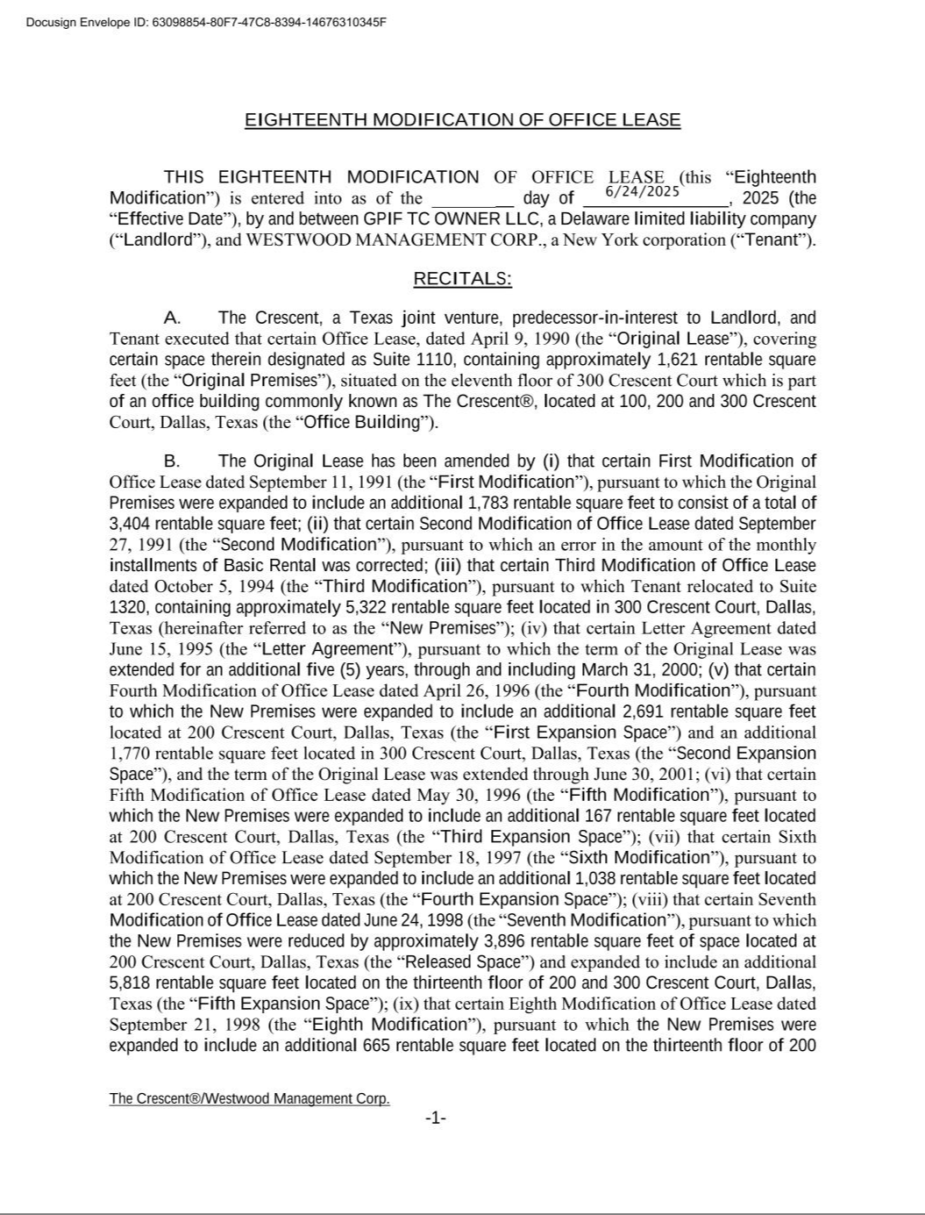

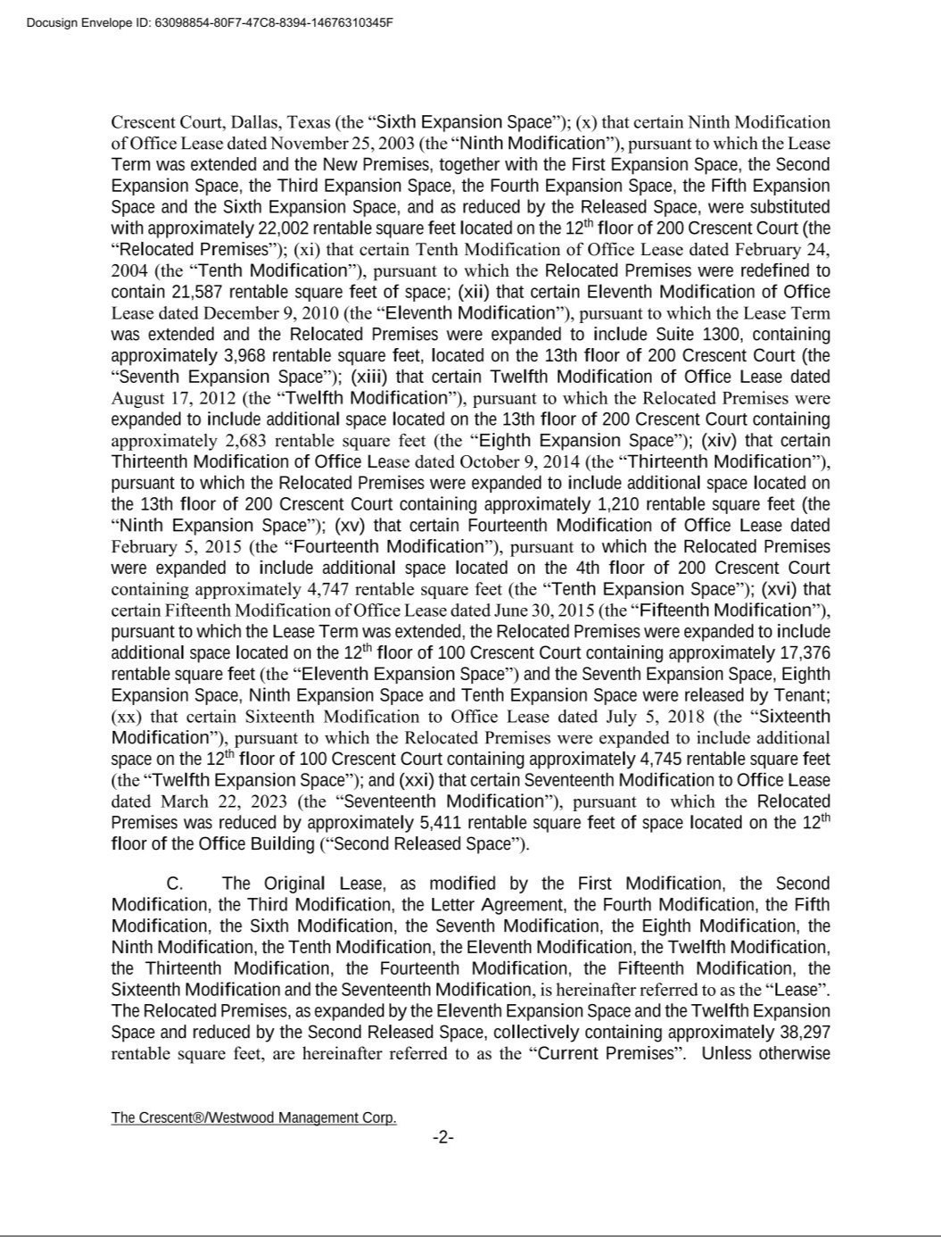

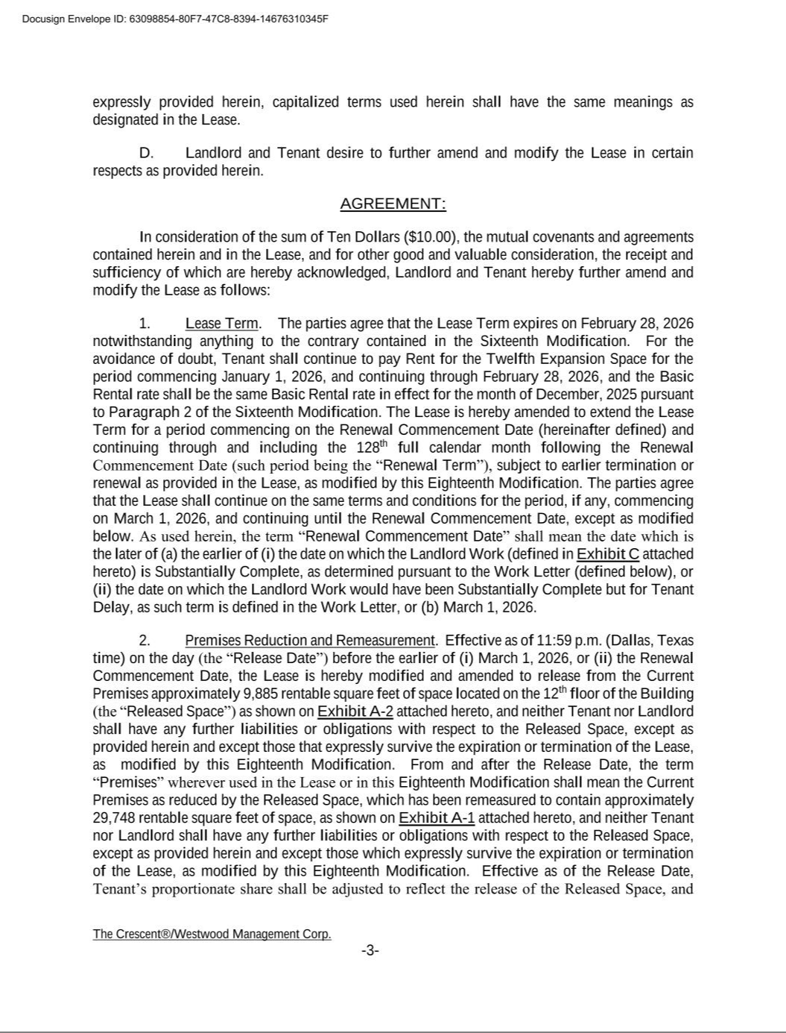

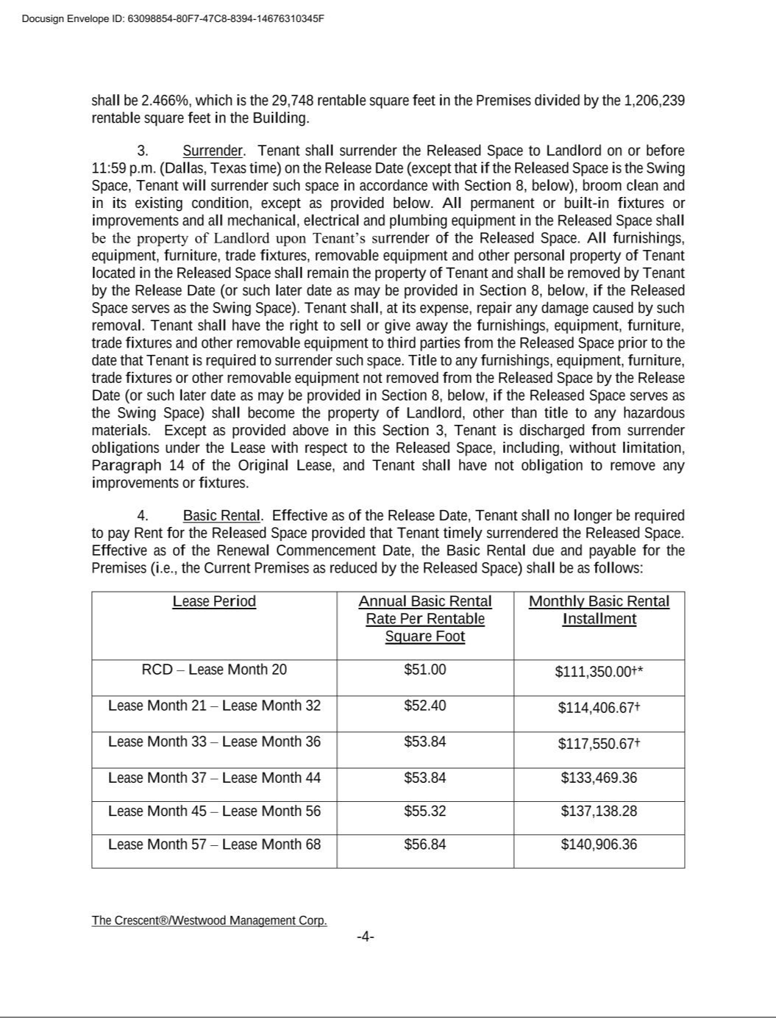

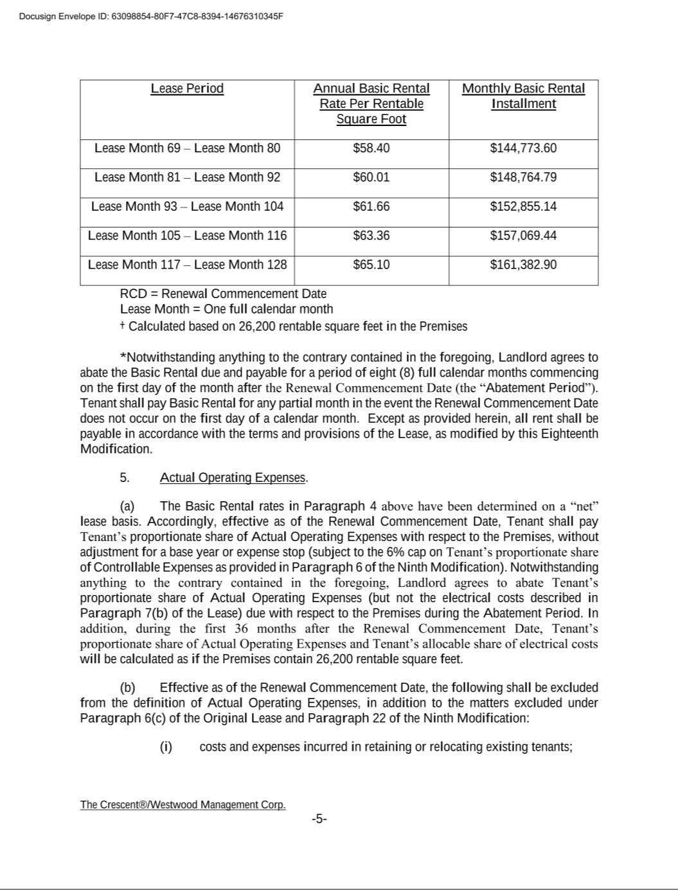

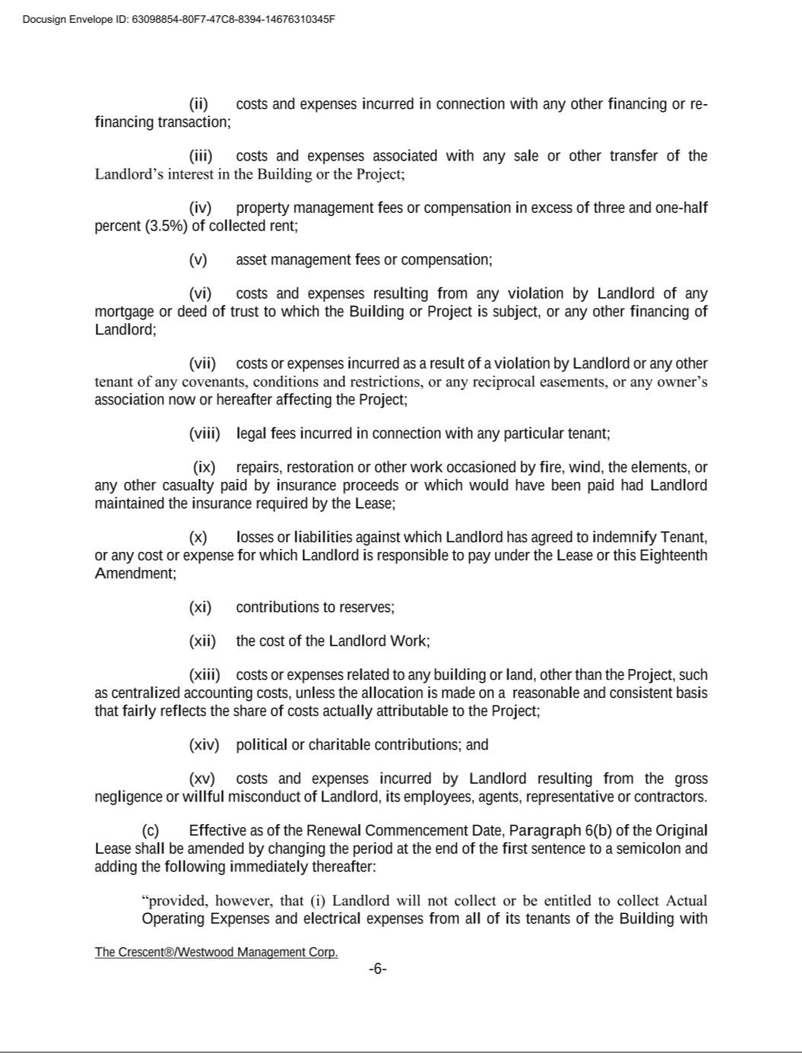

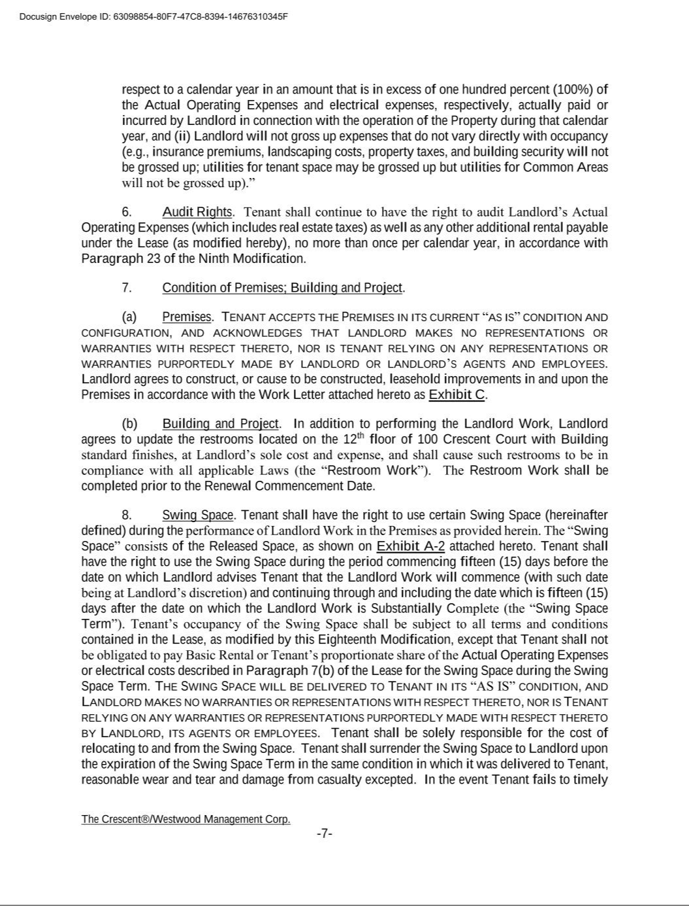

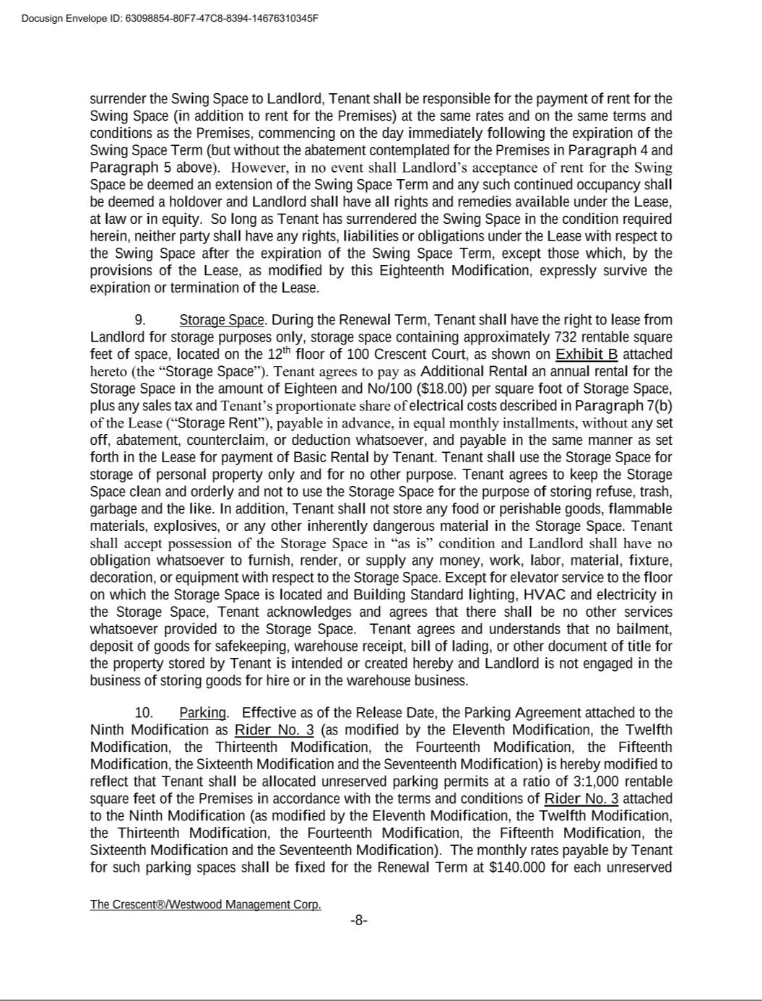

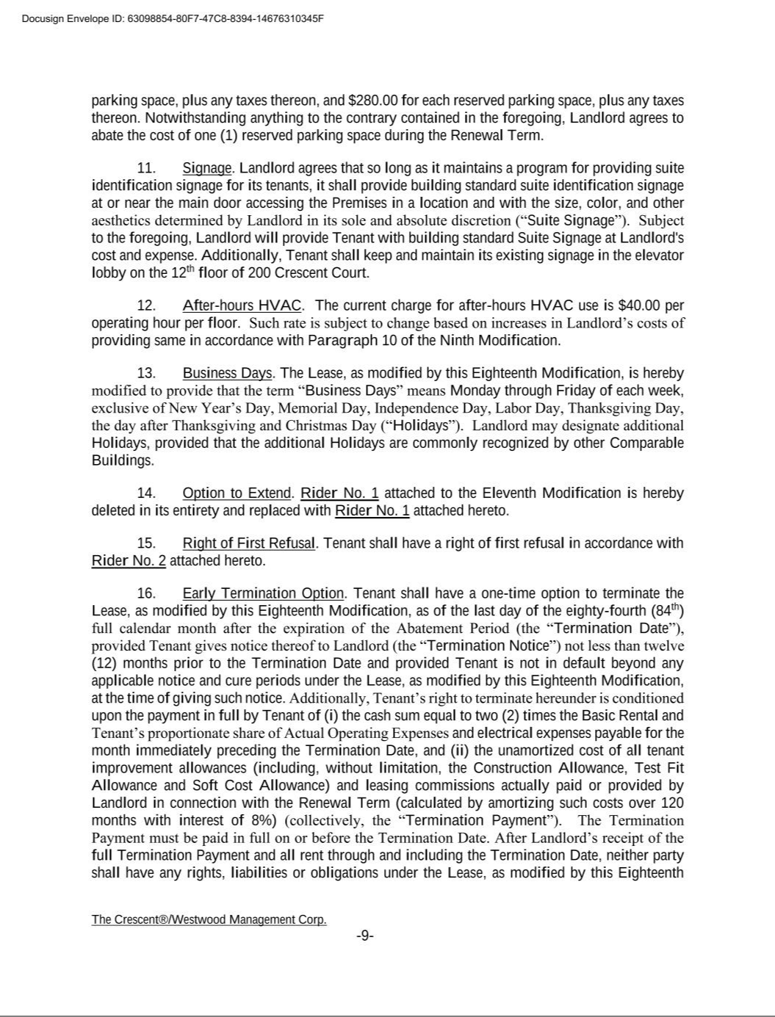

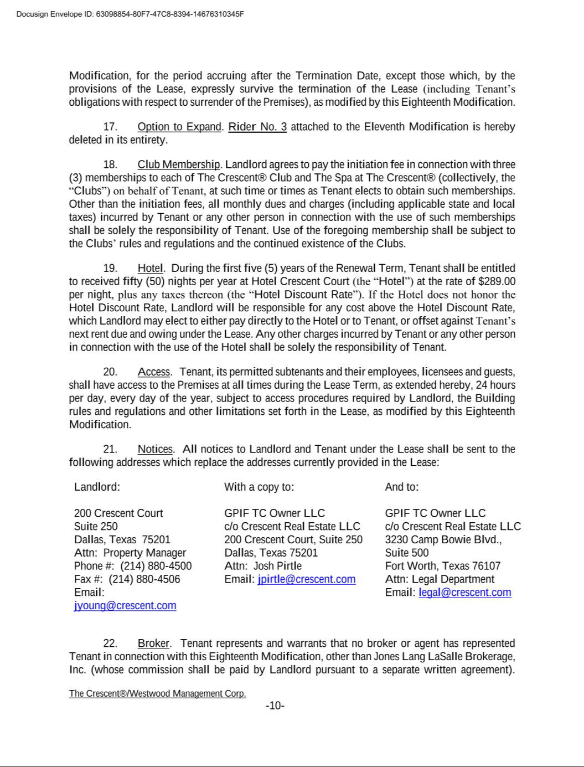

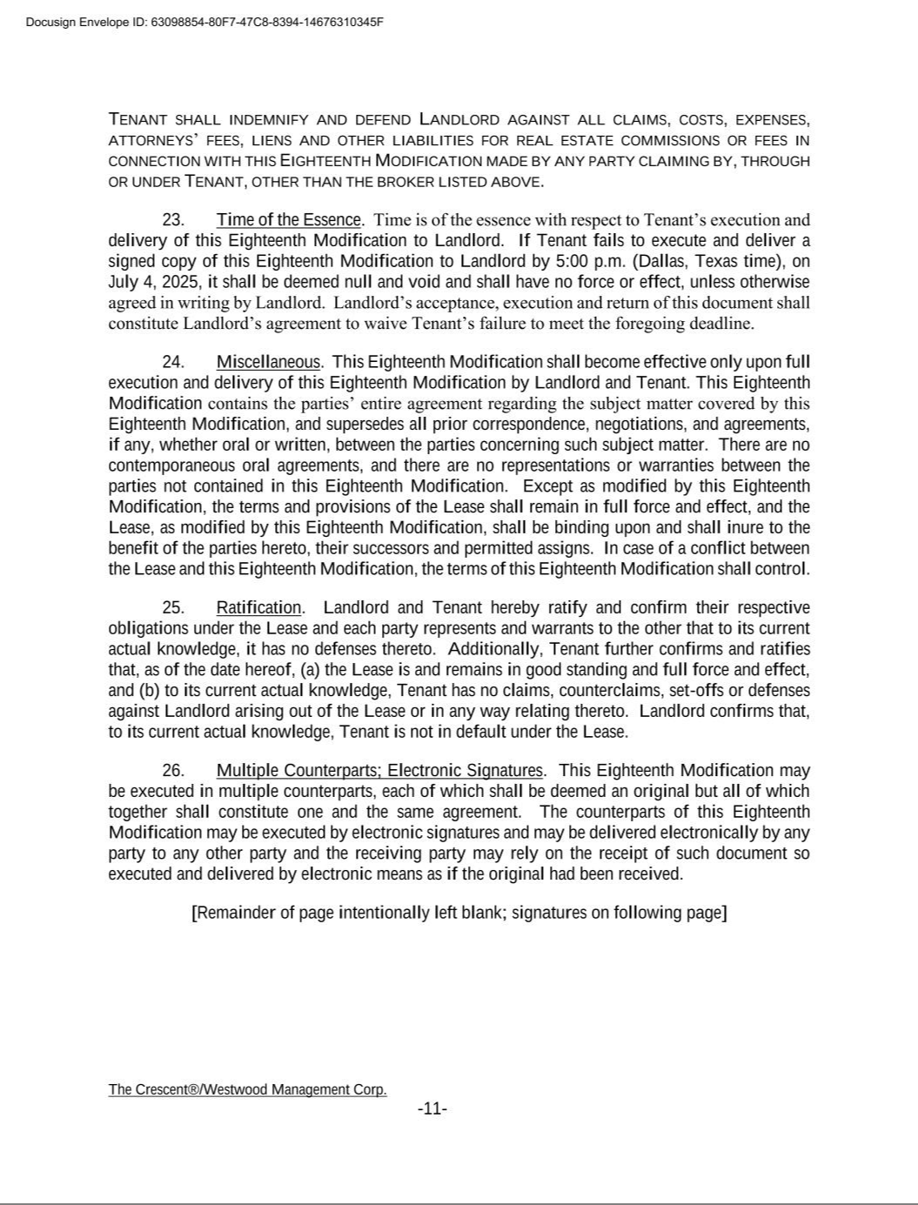

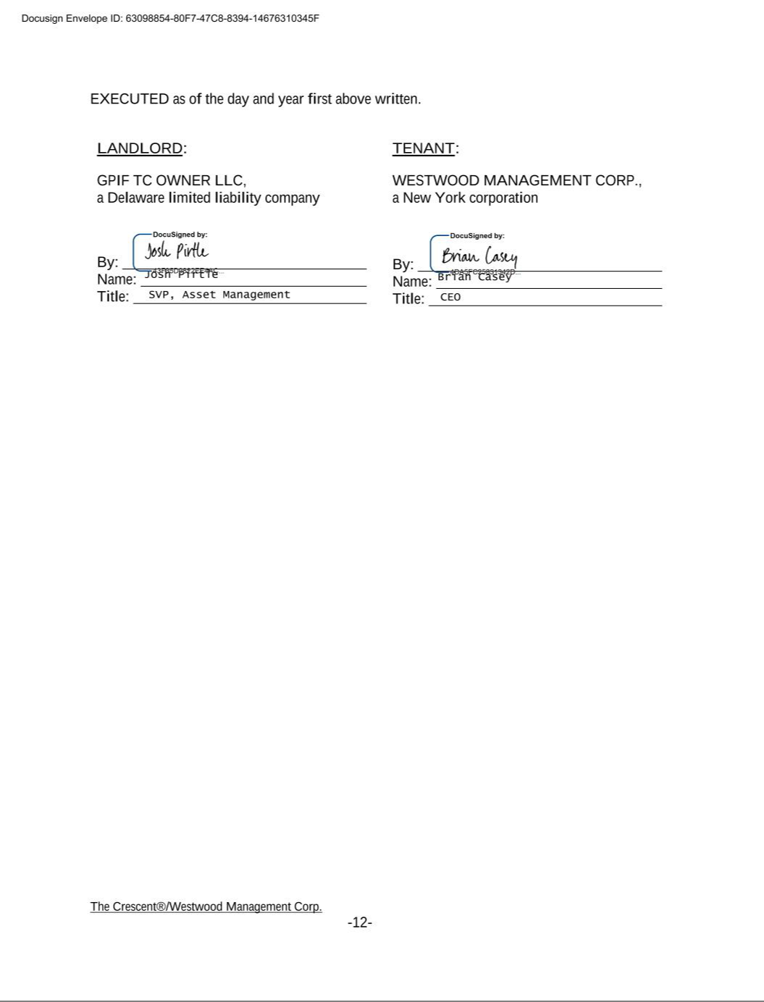

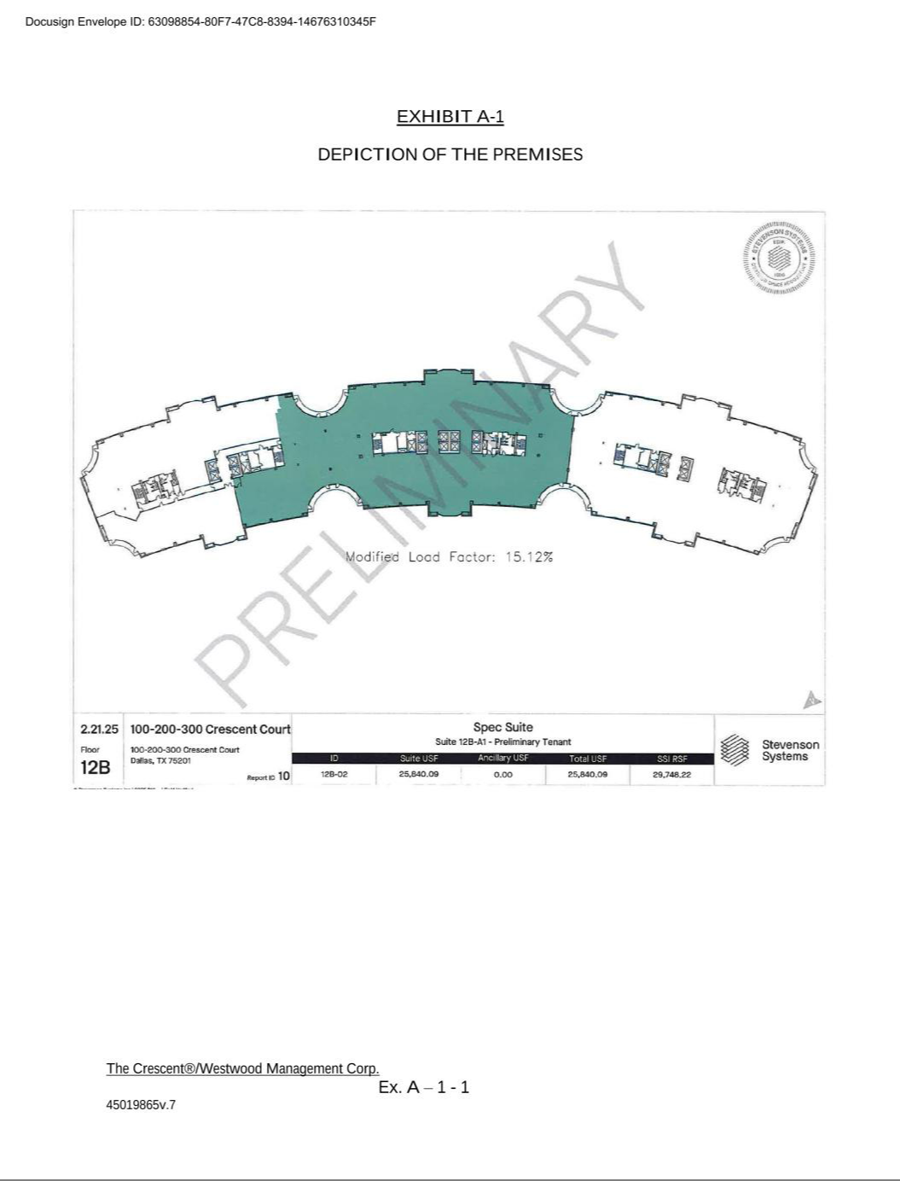

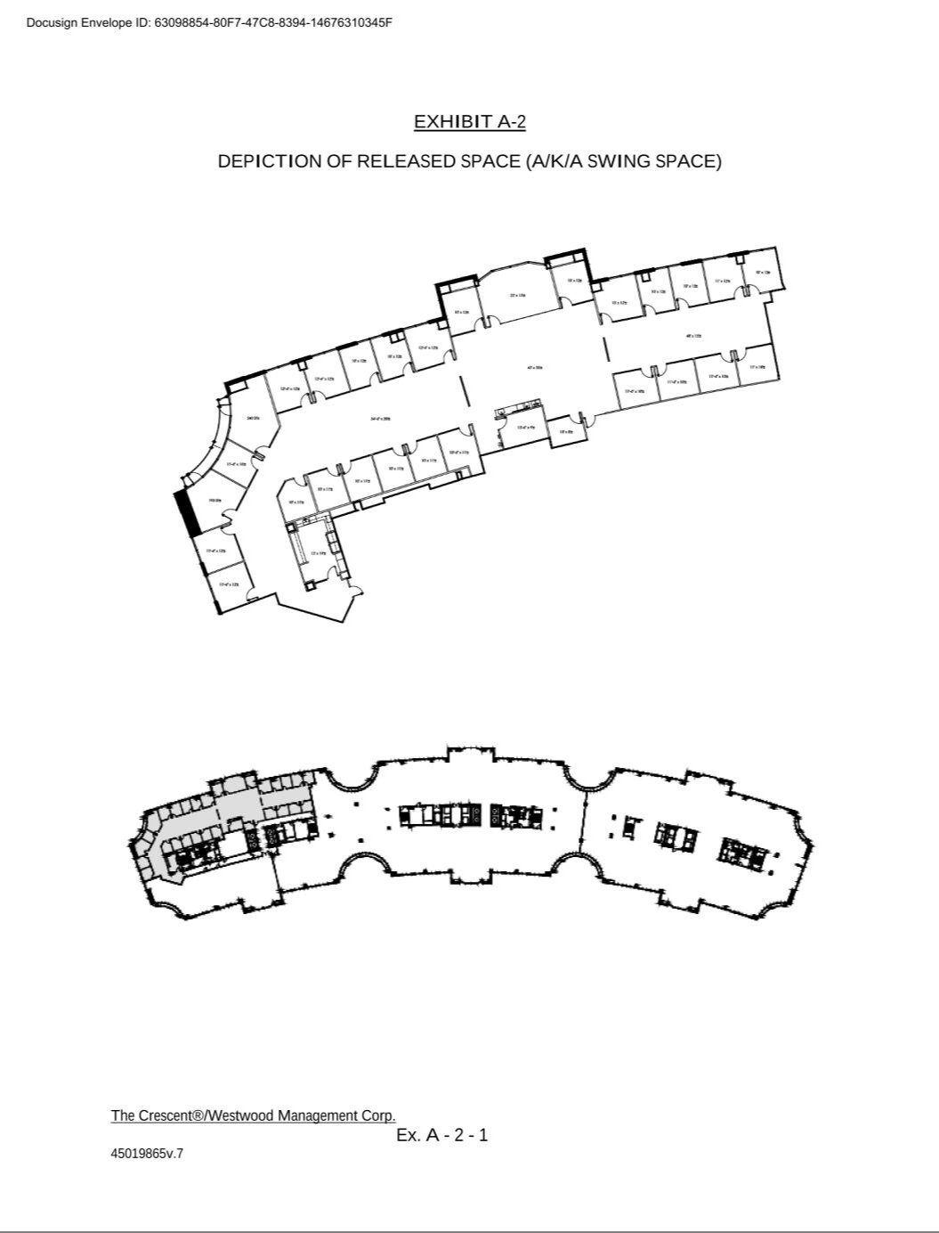

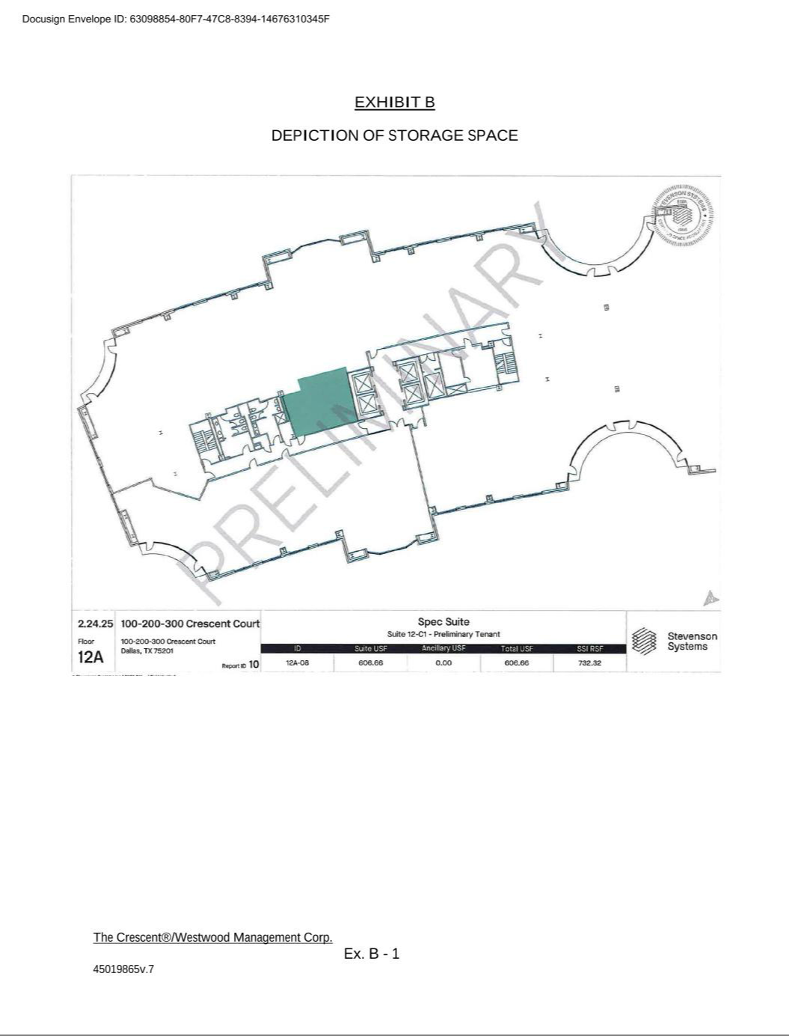

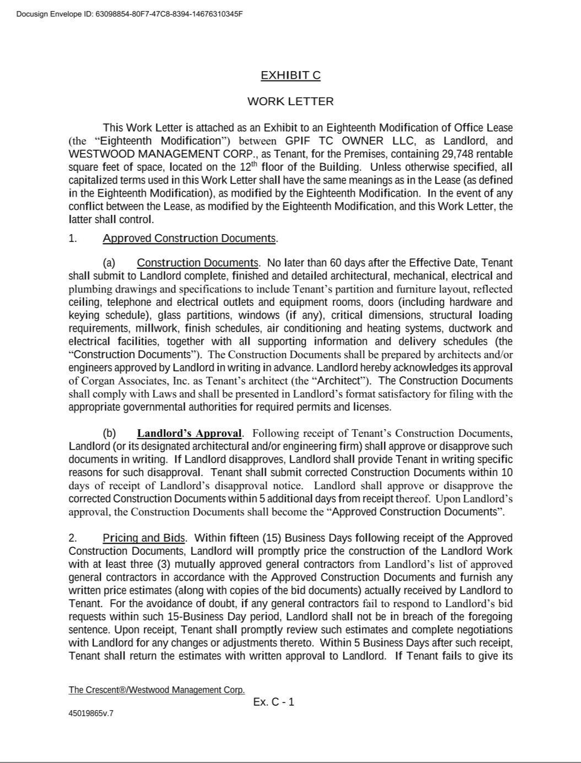

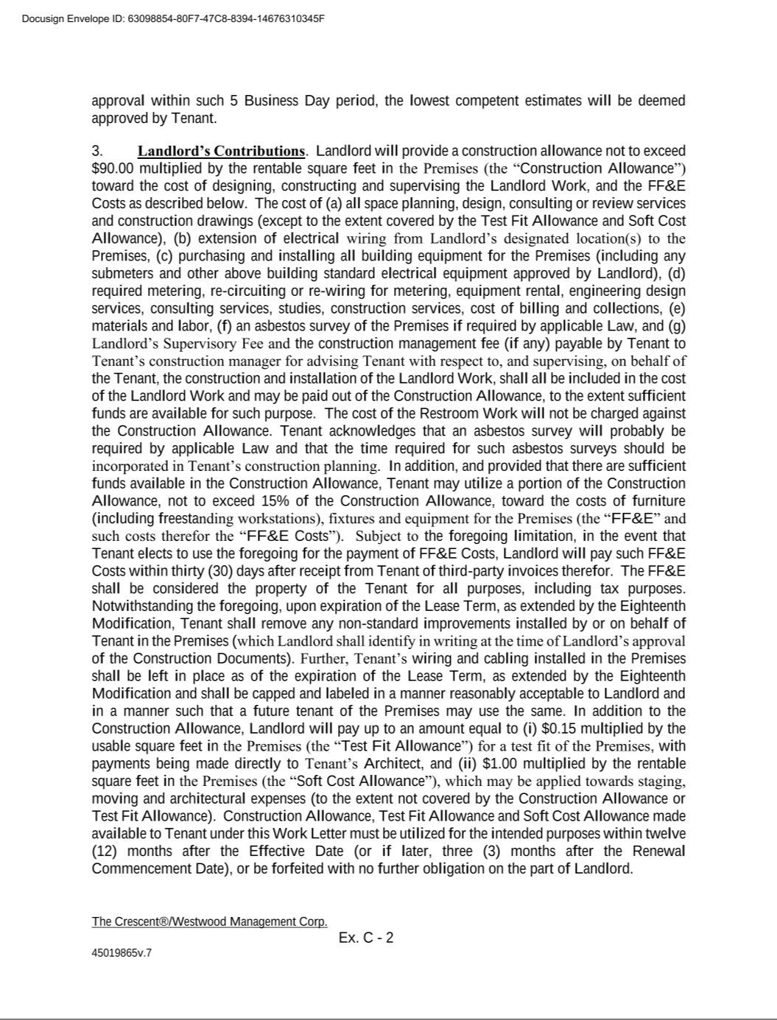

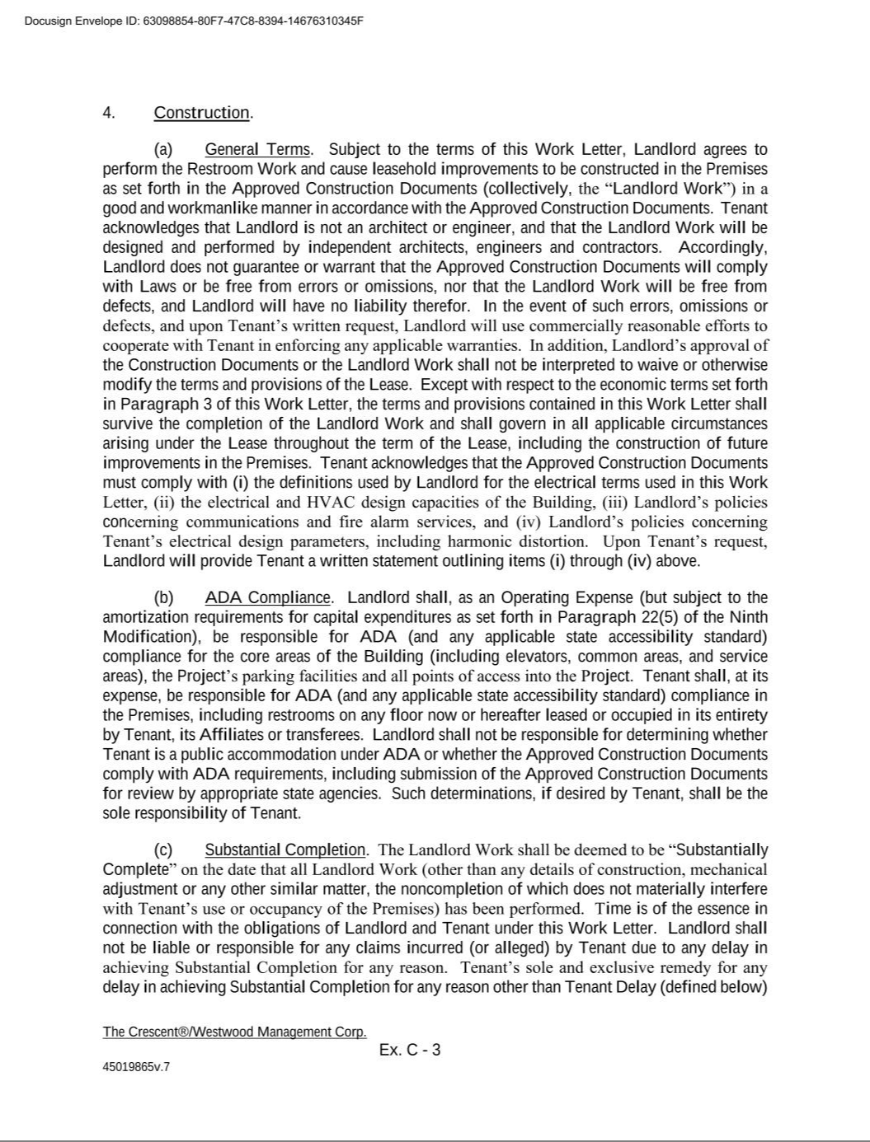

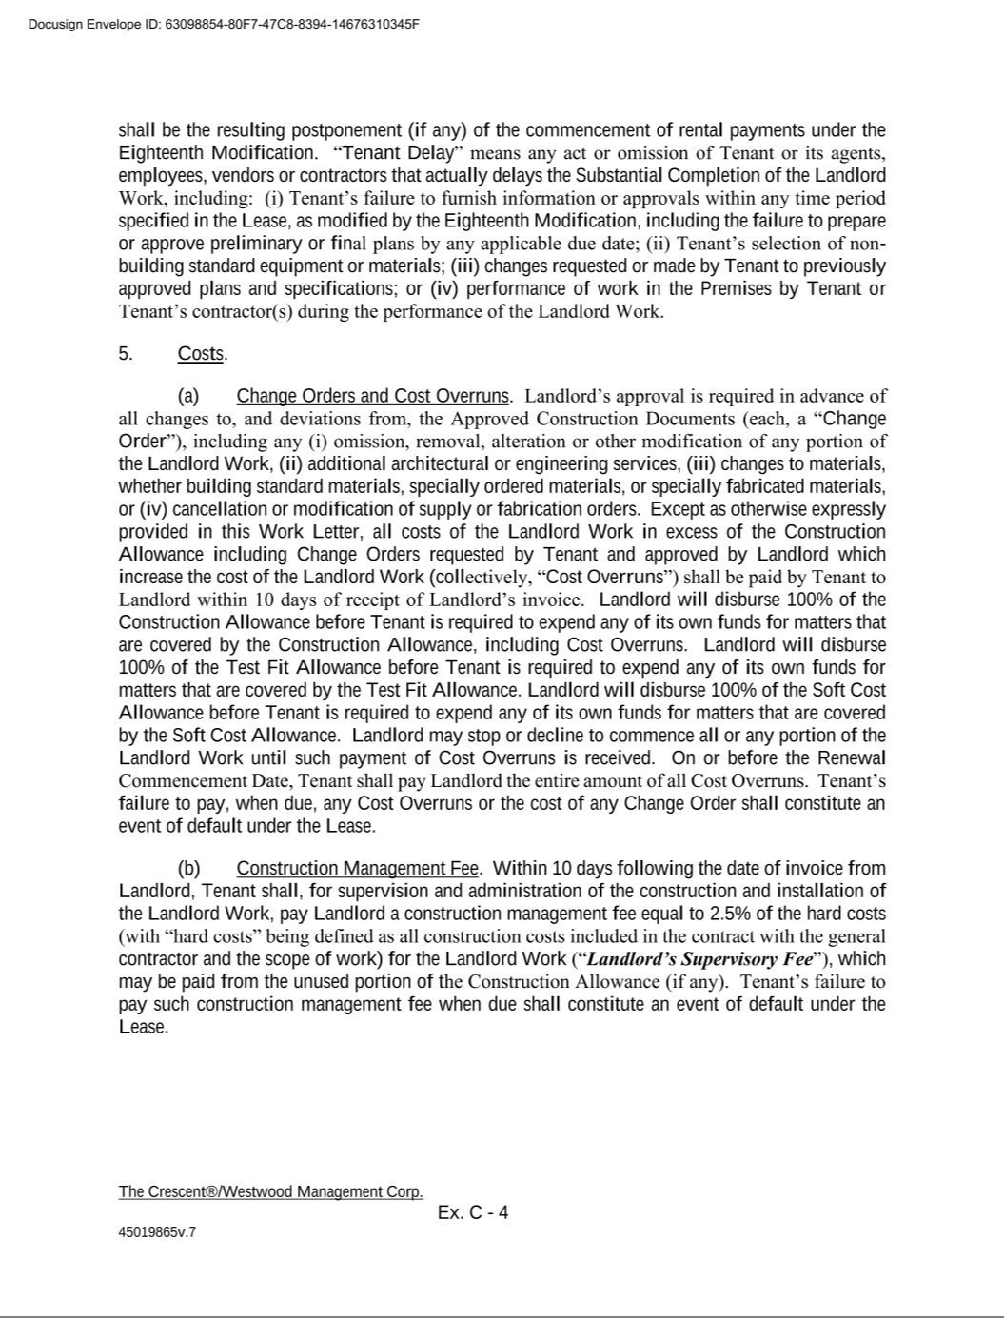

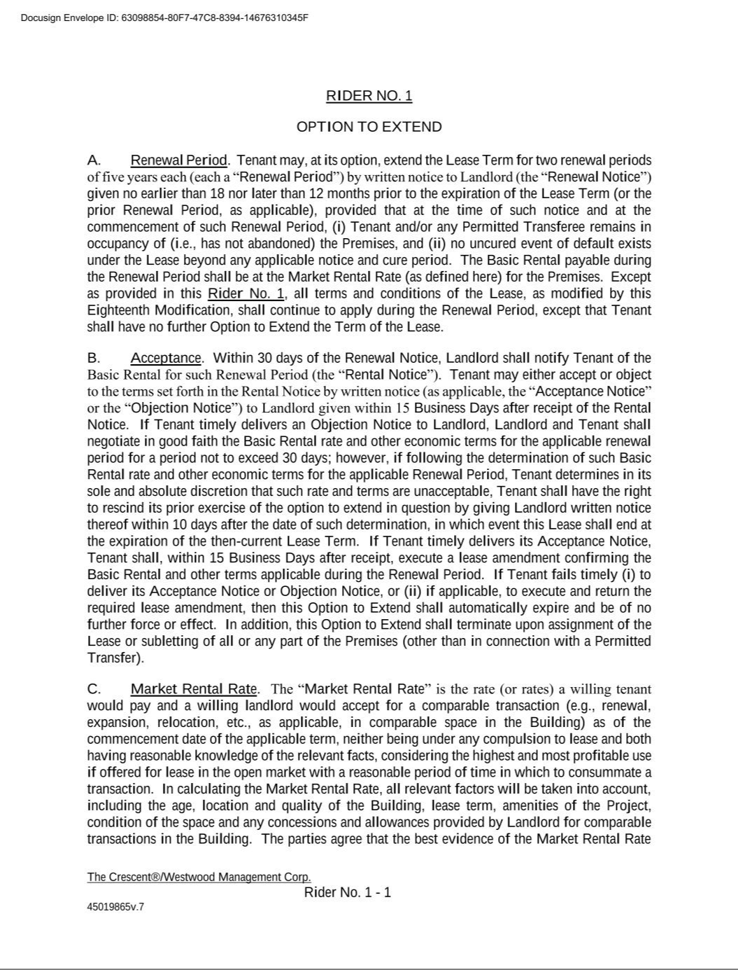



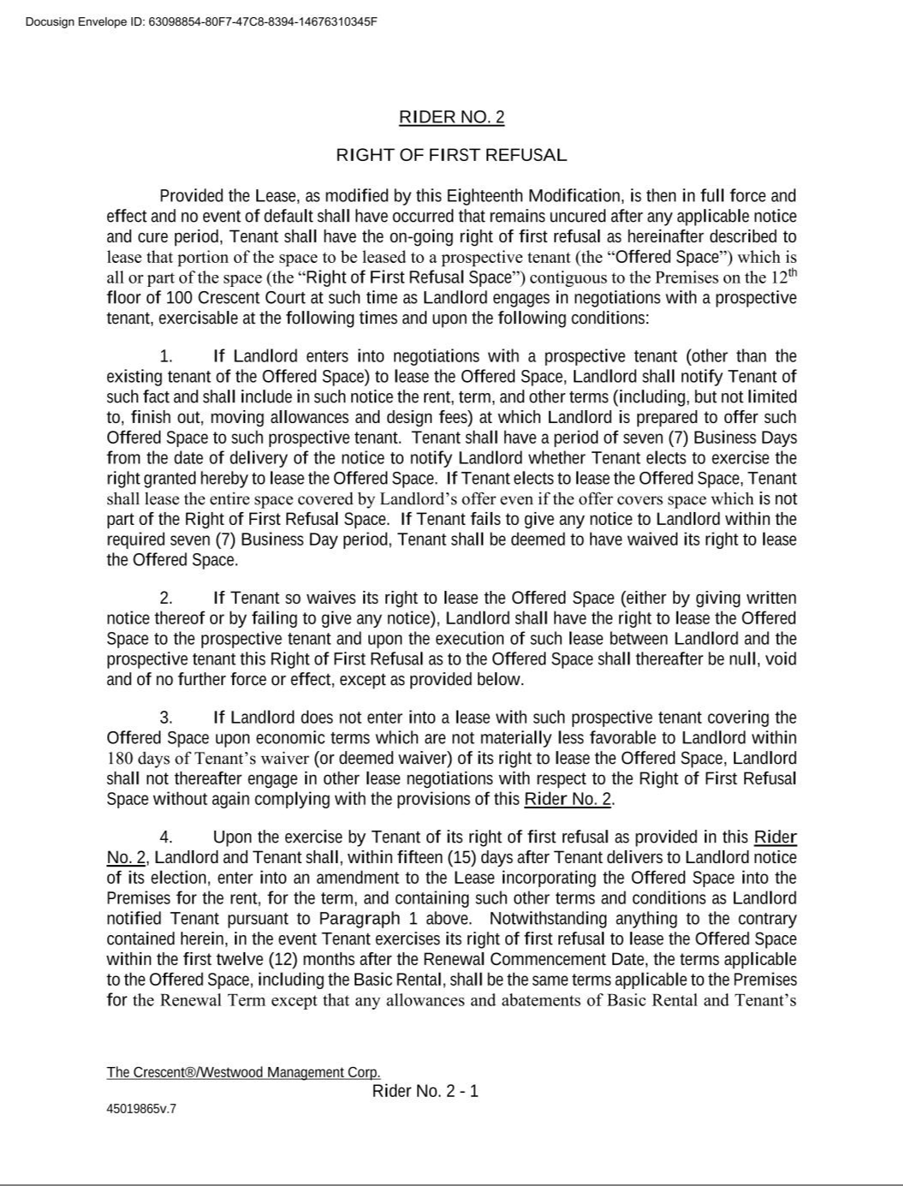

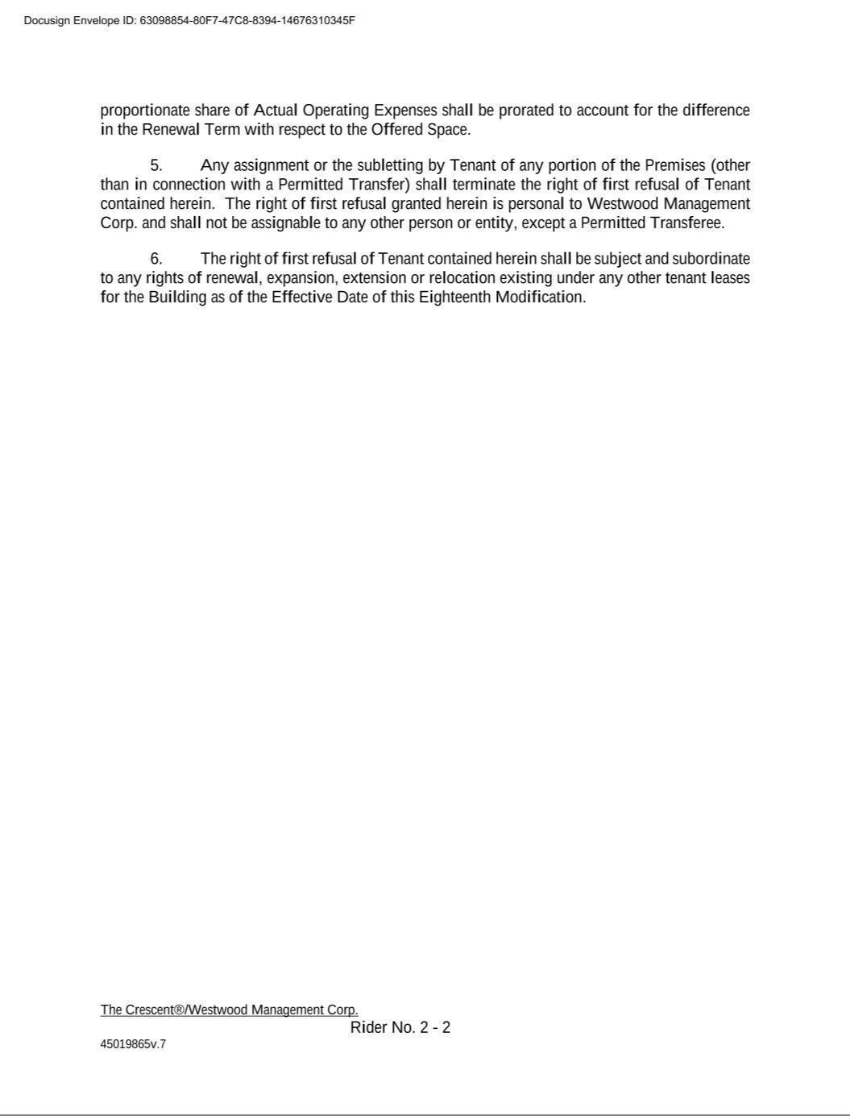

Exhibit 31.1

CERTIFICATION OF CHIEF EXECUTIVE OFFICER

PURSUANT TO

SECURITIES EXCHANGE ACT RULES 13a-14(a)

I, Brian O. Casey, certify that:

- I have reviewed this report on Form 10-Q of Westwood Holdings Group, Inc.;

- Based on my knowledge, this report does not contain any untrue statement of a material fact or omit to state a material fact necessary to make the statements made, in light of the circumstances under which such statements were made, not misleading with respect to the period covered by this report;

- Based on my knowledge, the financial statements, and other financial information included in this report, fairly present in all material respects the financial condition, results of operations and cash flows of the registrant as of, and for, the periods presented in this report;

- The registrant’s other certifying officer(s) and I are responsible for establishing and maintaining disclosure controls and procedures (as defined in Exchange Act Rules 13a-15(e) and 15d-15(e)) and internal control over financial reporting (as defined in Exchange Act Rules 13a-15(f) and 15d-15(f)) for the registrant and have:

  - Designed such disclosure controls and procedures, or caused such disclosure controls and procedures to be designed under our supervision, to ensure that material information relating to the registrant, including its consolidated subsidiaries, is made known to us by others within those entities, particularly during the period in which this report is being prepared;

  - Designed such internal control over financial reporting, or caused such internal control over financial reporting to be designed under our supervision, to provide reasonable assurance regarding the reliability of financial reporting and the preparation of financial statements for external purposes in accordance with generally accepted accounting principles;

  - Evaluated the effectiveness of the registrant’s disclosure controls and procedures and presented in this report our conclusions about the effectiveness of the disclosure controls and procedures, as of the end of the period covered by this report based on such evaluation; and

  - Disclosed in this report any change in the registrant’s internal control over financial reporting that occurred during the registrant’s most recent fiscal quarter (the registrant’s fourth fiscal quarter in the case of an annual report) that has materially affected, or is reasonably likely to materially affect, the registrant’s internal control over financial reporting; and

- The registrant’s other certifying officer(s) and I have disclosed, based on our most recent evaluation of internal control over financial reporting, to the registrant’s auditors and the audit committee of the registrant’s board of directors (or persons performing the equivalent functions):

  - All significant deficiencies and material weaknesses in the design or operation of internal control over financial reporting which are reasonably likely to adversely affect the registrant’s ability to record, process, summarize and report financial information; and

  - Any fraud, whether or not material, that involves management or other employees who have a significant role in the registrant’s internal control over financial reporting.

Dated: August 8, 2025

/s/ Brian O. Casey

Brian O. Casey

Chief Executive Officer

Exhibit 31.2

CERTIFICATION OF CHIEF FINANCIAL OFFICER

PURSUANT TO

SECURITIES EXCHANGE ACT RULES 13a-14(a)

I, Murray Forbes III, certify that:

- I have reviewed this report on Form 10-Q of Westwood Holdings Group, Inc.;

- Based on my knowledge, this report does not contain any untrue statement of a material fact or omit to state a material fact necessary to make the statements made, in light of the circumstances under which such statements were made, not misleading with respect to the period covered by this report;

- Based on my knowledge, the financial statements, and other financial information included in this report, fairly present in all material respects the financial condition, results of operations and cash flows of the registrant as of, and for, the periods presented in this report;

- The registrant’s other certifying officer(s) and I are responsible for establishing and maintaining disclosure controls and procedures (as defined in Exchange Act Rules 13a-15(e) and 15d-15(e)) and internal control over financial reporting (as defined in Exchange Act Rules 13a-15(f) and 15d-15(f)) for the registrant and have:

  - Designed such disclosure controls and procedures, or caused such disclosure controls and procedures to be designed under our supervision, to ensure that material information relating to the registrant, including its consolidated subsidiaries, is made known to us by others within those entities, particularly during the period in which this report is being prepared;

  - Designed such internal control over financial reporting, or caused such internal control over financial reporting to be designed under our supervision, to provide reasonable assurance regarding the reliability of financial reporting and the preparation of financial statements for external purposes in accordance with generally accepted accounting principles;

  - Evaluated the effectiveness of the registrant’s disclosure controls and procedures and presented in this report our conclusions about the effectiveness of the disclosure controls and procedures, as of the end of the period covered by this report based on such evaluation; and

  - Disclosed in this report any change in the registrant’s internal control over financial reporting that occurred during the registrant’s most recent fiscal quarter (the registrant’s fourth fiscal quarter in the case of an annual report) that has materially affected, or is reasonably likely to materially affect, the registrant’s internal control over financial reporting; and

- The registrant’s other certifying officer(s) and I have disclosed, based on our most recent evaluation of internal control over financial reporting, to the registrant’s auditors and the audit committee of the registrant’s board of directors (or persons performing the equivalent functions):

  - All significant deficiencies and material weaknesses in the design or operation of internal control over financial reporting which are reasonably likely to adversely affect the registrant’s ability to record, process, summarize and report financial information; and

  - Any fraud, whether or not material, that involves management or other employees who have a significant role in the registrant’s internal control over financial reporting.

Dated: August 8, 2025

/s/ Murray Forbes III

Murray Forbes III

Chief Financial Officer and Treasurer

Exhibit 32.1

CERTIFICATION PURSUANT TO

18 U.S.C. SECTION 1350,

AS ADOPTED PURSUANT TO

SECTION 906 OF THE SARBANES-OXLEY ACT OF 2002

In connection with the Quarterly Report of Westwood Holdings Group, Inc. (the “Company”) on Form 10-Q for the period ended June 30, 2025 as filed with the Securities and Exchange Commission on the date hereof (the “Report”), I, Brian O. Casey, President & Chief Executive Officer of the Company, certify, pursuant to 18 U.S.C. § 1350, as adopted pursuant to § 906 of the Sarbanes-Oxley Act of 2002, that, to the best of my knowledge:

- The Report fully complies with the requirements of section 13(a) or 15(d) of the Securities Exchange Act of 1934 (15 U.S.C.78m or 78o(d)); and

- The information contained in the Report fairly presents, in all material respects, the financial condition and results of operations of the Company.

Dated: August 8, 2025

/s/ Brian O. Casey

Brian O. Casey

Chief Executive Officer

A signed original of this written statement required by Section 906 has been provided to Westwood Holdings Group, Inc. and will be retained by Westwood Holdings Group, Inc. and furnished to the Securities and Exchange Commission or its staff upon request. The foregoing certification is being furnished solely pursuant to 18 U.S.C. Section 1350 and is not being filed as part of the Report or as a separate disclosure document.

Exhibit 32.2

CERTIFICATION PURSUANT TO

18 U.S.C. SECTION 1350,

AS ADOPTED PURSUANT TO

SECTION 906 OF THE SARBANES-OXLEY ACT OF 2002

In connection with the Quarterly Report of Westwood Holdings Group, Inc. (the “Company”) on Form 10-Q for the period ended June 30, 2025 as filed with the Securities and Exchange Commission on the date hereof (the “Report”), I, Murray Forbes III, Chief Financial Officer of the Company, certify, pursuant to 18 U.S.C. § 1350, as adopted pursuant to § 906 of the Sarbanes-Oxley Act of 2002, that, to the best of my knowledge:

- The Report fully complies with the requirements of section 13(a) or 15(d) of the Securities Exchange Act of 1934 (15 U.S.C. 78m or 78o(d)); and

- The information contained in the Report fairly presents, in all material respects, the financial condition and results of operations of the Company.

Dated: August 8, 2025

/s/ Murray Forbes III

Murray Forbes III

Chief Financial Officer and Treasurer

A signed original of this written statement required by Section 906 has been provided to Westwood Holdings Group, Inc. and will be retained by Westwood Holdings Group, Inc. and furnished to the Securities and Exchange Commission or its staff upon request. The foregoing certification is being furnished solely pursuant to 18 U.S.C. Section 1350 and is not being filed as part of the Report or as a separate disclosure document.

